MICROBIAL SOURCE TRACKING IN THE MENAI STRAIT, NORTH WALES.
  - Authors: Mannion, F., Gregory, C., Holding, P., Sorby, R., Winterbourn, B., Farkas, K., Allender, S., Corner, R., Tuson, K., Malham, S., Le Vay, L.

  - Date: 14/12/2022
  - Version: Draft V2

This report was prepared in collaboration with DEEPDOCK LIMITED Dŵr CYMRU CYNFYNGEDIG, MENAI STRAIT FISHERY ORDER MANAGEMENT ASSOCIATION, AND NORTH WALES RIVERS TRUST LIMITED, who provided support and in-kind contribution to the project activity.

The Shellfish Centre RD&I operation is part-funded by the EU’s West Wales and the Valleys European Regional Development Fund (ERDF) Operational Programme through the Welsh Government.

Context

A collaborative project was undertaken by Bangor University, Deepdock Ltd, Dŵr Cymru Cynfyngedig, Menai Strait Fishery Order Management Association, and North Wales Rivers Trust Ltd to assess bacterial and viral concentrations and investigate sources of contamination to the Menai Strait East Fishery Order area. Wastewater discharges, agricultural and industrial activities can pollute the coastal environment. As bivalve shellfish are filter-feeders, they can accumulate chemical and microbiological contaminants. Pollutants can include human pathogens and the consumption of contaminated shellfish raw can result in human illness. Wastewater infrastructure malfunction, the operation of Combined Sewer Overflows during high rainfall events, and leaking septic tanks are all associated with contamination of shellfish with human pathogens. The water quality of shellfish production areas is classified based on monitoring of E. coli in shellfish flesh, an indicator of faecal bacterial contamination, which may originate from human, agricultural livestock and wildlife sources. Under the Official Control Regulations (OCR), monthly samples are taken at Representative Monitoring Points (RMPs) within a production area. Shellfish beds in the Menai Straits are largely classified as B class waters (currently, one out of six is seasonal A class). Historically the Menai East Several Order has been one of the leading production areas of mussels in the UK, sending products wholesale to European markets. Since EU-exit, live bivalve mollusc exports to the EU from B class waters have been prohibited, and hence efforts to improve water quality and/or application of the OCR assessment of human health risks are critical to the resilience of the industry.
Shellfish, shellfish growing waters and freshwater inputs were frequently monitored at several locations including Representative Monitoring Points (RMPs) within the Fishery Order and the rivers Afon Ogwen, Afon Cegin and Afon Adda; for the presence and quantity of bacterial and viral indicators of microbial contamination. The project combined sampling with environmental data from several sources to provide a wide-ranging evaluation of microbial contamination in the Eastern Menai Strait Fishery Order area. It investigated sources of contamination, conducted pathogenic virus surveillance, investigated the integrity and infectivity of human viruses in shellfish, the relationship between faecal indicator bacteria, viral indicators and pathogenic viruses in surface waters and shellfish; and how this varies temporally and spatially in the study area, including investigating the effect of distinct rainfall events. The project also made a comparison of methods for the quantification of E. coli in shellfish and began the development of models to predict shellfish-associated risks in relation to environmental conditions.

Objectives

This project aimed to:
- Understand microbial sources and impacts on shellfish production areas within Menai Strait, and their human or animal origins.
- Understand temporal and spatial patterns of contamination and the effect of weather events.
- Validate and improve network and source apportionment models used by Welsh Water.
The information developed can help inform:
- The potential benefits of investments in wastewater infrastructure.
- The potential benefits of improvements to agricultural catchment management.
- The effectiveness and reliability of environmental predictors for shellfish hygiene.
- The potential for adaptive management, based on using environmental indictors to predict periods of high/low contamination of shellfish.

Key findings
The key findings from the project were:
- Data show substantial human wastewater-derived contamination in the study area.
  - CrAssphage and mastadenovirus F were frequently detected in all sample types.
- There was less evidence of animal-derived contamination to the study area.
  - Atadenovirus was very rarely detected.
- Hepatitis A and E viruses and human sapoviruses were not detected in any of the samples. We detected human noroviruses sporadically in all sample types.
- The results showed evidence of noroviruses in mussels occasionally.
  - Intact noroviruses, or infective adenoviruses, were not detected by integrity or culture-based assays, respectively.
    - Presence according to PCR signal may not indicate human health risk.
- E. coli concentration did not correlate with human norovirus in any sample type and was only weakly associated with human indicator viruses in mussels.
- CrAssphage, which is mostly associated with human gut flora, was significantly associated with norovirus concentrations in mussels and river water, indicating its value as an indicator of human viral contamination.
  - Human mastadenovirus F was less strongly and significantly associated. Its level was more frequently below the Limit of Quantification for the method.
- The Afon Adda is contaminated with faecal indicator bacteria at high concentration.
  - Viral indicators suggest a large human-derived component.
- The Afon Ogwen has the largest discharge, and its E. coli concentration predicts E. coli concentration in mussels at all RMPs studied more strongly than the Afon Adda or Afon Cegin.
  - Viral indicators suggest a large human-derived component here also.
- Based on the relatively short time series of data available, it seems unlikely that application of the pour plate method for enumeration of E. coli in shellfish would result in any change in full year classifications of any the four areas investigated. However, the seasonal pattern of pour plate results, with less frequent results >700 and higher proportion of results <230, indicates some potential for seasonal A/B classifications in the future, if this method were to be applied to official control sampling. This is by no means a guaranteed outcome, as a longer three-year data set would be required, but is worth investigation as it would represent a significant improvement in the resilience of mussel businesses operating in Menai East Several Order that are dependent on exports to the EU.
- Rainfall events can result in brief spikes in E. coli flux from the Afon Ogwen.
  - The effect of brief spikes in microbial input from rivers on shellfish beds and their RMPs will depend on concurrent tidal state because the rivers follow intertidal channels at low water and will create more diffuse plumes over shellfish beds at higher states of tide.
- A preliminary model explained 83% of the variability in E. coli concentrations in mussels at the Ogwen Channel Representative Monitoring Point from the concentration of E. coli in the discharge water of the Afon Ogwen. Concentrations of E. Coli in discharge from this river also strongly correlate with concentration in mussels at all RMPs sampled.
  - It should be noted that significant correlations do not necessarily imply causation. For example, high E. coli levels in the Afon Ogwen discharge waters may also coincide with high general surface water flow conditions, when CSOs closer to the shellfish beds may overflow and contribute to E. coli levels observed in shellfish. The predictive modelling analysis will be repeated when CSO Event Duration Monitoring data for the study area are available.

Table of Contents

MICROBIAL SOURCE TRACKING IN THE MENAI STRAIT, NORTH WALES 1
Context 2
Objectives 3
Key findings 3
Table of Contents 5
1. Introduction 7
1.1 Research background 7
1.2 Menai Strait fishery order 9
1.3 Study site information 9
2. Methods 12
2.1 Sampling design 12
2.1.1 Routine sampling of shellfish, seawater & river water samples 12
2.1.2 Environmental data collection 14
2.1.3 Event sampling 16
2.1.4. Passive sampling 18
2.2 E. coli quantification in shellfish 18
2.2.1 Dilution tube MPN method 19
2.2.2 Pour plate method 20
2.2.3 Impedance method 20
2.3 E. coli quantification in water 20
2.4 Virus quantification 20
2.4.1 Virus concentration from water 20
2.4.2 Virus extraction from shellfish for quantification 21
2.4.3 Virus extraction from shellfish for infectivity assays 21
2.4.4 Virus integrity assay 21
2.4.5 Virus culture 21
2.4.6 Virus nucleic acid extraction 21
2.4.7 Virus quantitative PCR 22
2.4.8 Quality control 22
2.5 Statistical analysis 22
2.5.1 Comparisons of sites by crAssphage concentration 22
2.5.2 Correlation matrices 22
2.5.3 Sources of E. coli 23
3. Results 24
3.1 Spatio-temporal surveillance of viruses 24
3.1.1 Viral abundance and contamination source tracking 24
3.1.2 Virus integrity and infectivity 28
3.1.3 Correlation between faecal indicators, human viruses, and environmental markers 28
3.2 Faecal indicator bacteria 33
3.2.1 Rivers 33
3.2.2. Shellfish 35
3.3 Event sampling 38
3.3.1 Event I 38
3.3.2 Event II 41
3.3.3 Event III 42
3.4 E. coli quantification in shellfish, methodology comparison 46
4. Discussion 51
4.1 Sources of contamination 51
4.2 Pathogenic virus surveillance 51
4.5 Comparison of the viral indicators 52
4.5.1 River waters 52
4.5.2 Sea water 52
4.5.3 Mussels 52
4.6 Differences within the study area 53
4.6.1 Rivers 53
4.6.2. Shellfish 53
4.7 Rainfall events 53
4.8 Tidal Influences 54
4.9 Representativeness of RMPs 54
4.10 E. coli quantification in shellfish – method comparisons 54
4.11 Potential for environmental predictors of shellfish hygiene 55
4.12 Future modelling work 57
5. Acknowledgements 58
6. Appendices 59
7. References (and/or Bibliography) 65

1. Introduction

1.1 Research background
Wastewater discharges, agricultural and industrial activities can pollute the coastal environment. As bivalve shellfish are filter-feeders, they can accumulate chemical and microbiological contaminants. Pollution can include human pathogens and the consumption of contaminated shellfish raw can result in human illness (Bellou et al., 2012). Wastewater infrastructure malfunction, the operation of Combined Sewer Overflows (CSOs) during high rainfall events, and leaking septic tanks are all associated with contamination of shellfish with human pathogens (Droppo et al., 2009).
In the UK, retained EU law regulations 853/2004 and 2019/627 require that shellfish production areas are monitored for levels of Escherichia coli (E. coli), used as an indicator of faecal contamination. Representative Monitoring Points (RMPs), and the spatial extent of the classification zones which they represent, are recommended after a sanitary survey. Zones are classified from class A to C, determining the post-harvest treatment level required (Table 1.1). In the UK, classification is based on compliance over a three-year period. In England and Wales there is a long term-B classification, based on a five-year period. Shellfish production areas can also be awarded with a seasonal A/B classification.

Table 1.1. Outline of the classification system for UK shellfish beds under retained EU laws 853/2004 and 2019/627.
Classification | Samples Required | E. coli Level Limits | Post-harvesting Treatment Options
A | Minimum of 10 samples per annum.  (approx. monthly) | 80% of samples must be ≤230 E. coli/100g.  No result > 700  E. coli/100g. | Shellfish can be harvested directly for human consumption.
B | Minimum of 8 samples per annum.  (approx. monthly) | 90% of samples must be ≤4,600 E. coli/100g.  No result > 46,000 E. coli/100g. | Purification in an approved establishment.  Relaying for at least one month in a Class A relaying area.  An EC approved heat treatment process
C | Minimum of 8 samples per annum.  (approx. monthly) | All samples ≤46,000 E. coli/100g. | Relaying for at least 2 months in an approved Class B relaying area followed by treatment in an approved purification centre.  Relaying for at least 2 months in an approved class B relaying area.  An EC approved heat treatment process.
Prohibited |  | Results >46,000  E. coli/100g. | Shellfish from areas with consistently prohibited level results must not be subject to production or harvest.
E. coli quantification for shellfish water classification must use an accredited method. The most commonly used approach is the ISO 16649-3:2015 Most Probable Number (MPN) Method for the Quantification of E. coli in Shellfish Flesh. This is an extinction dilution method, which is inherently variable (Jarvis et al., 2010) and for which the shellfish industry has raised reliability concerns with respect to occasional unexplained high results. Alternative accredited methods exist and have been compared with the MPN method (Walker et al., 2018; Pol-Hofstad & Jacobs-Reitsma 2021; Malham et al., in prep.). Further comparisons are needed to evaluate the reproducibility and reliability of different methods, and the implications for production area classification and the protection of human health.
E. coli is widely used as a microbial quality indicator for environmental samples, but it may be a poor indicator for the presence of human pathogens (Devane et al., 2020; Harwood et al., 2014; Nguyen et al., 2018; Oliver et al., 2016; Winterbourn et al., 2016). E. coli may originate from livestock and wild animals and have different persistence in aquatic environments and in shellfish than human viruses, protozoa and other bacteria (Baggi et al., 2001; Espinosa et al., 2009). The usefulness of viral indicators for wastewater-derived contamination has been assessed (Farkas et al., 2020). The most promising candidates are human adenoviruses (endemic enteric pathogens causing mild or asymptomatic infections) and crAssphage (bacteriophage commonly associated with human gut bacteria). These viruses are found at high concentrations in wastewater and wastewater-polluted environments, and their persistency is comparable with noroviruses (NoV GI, GII) and other harmful enteric viruses. Atadenovirus, associated with deer, cattle and sheep, may be suitable indicators of animal-associated pollution (Wolf et al., 2010). Non-microbial water qualities (salinity, turbidity, nutrient concentration) may also predict sanitary conditions. More studies are necessary to better understand the relationship between potential indicators and human pathogenic viruses in the aquatic environment, especially in areas used for shellfish harvesting.
The frequency of official control monitoring does not adequately assess the temporal pattern of microbial contamination, or the dynamics associated with high rainfall events to inform adaptive management. It also does not provide information on whether contamination is sewage-derived or agriculture-related or explore the sources of contamination in any way. A range of statistical models for shellfish waters are being developed to predict spatial and temporal pollution in estuarine waters, with some approaches explaining exceedances in shellfish waters with 100 and 97% predictive power (Zimmer- Faust et al., 2018). In contrast, the use of predictive models for shellfish waters to predict E. coli in shellfish flesh, is limited (Bougeard et al., 2011; Campos et al., 2011; Schmidt et al., 2018).
Therefore, it is important to understand sources and patterns of E. coli contamination in shellfish fisheries and the relationship with human pathogens and other potential hygiene indicators. If shellfish hygiene can be predicted reliably then harvesting periods could be managed adaptively. There may also be scope for changes in implementation of official control regulations. This project aimed to better understand patterns of faecal contamination and provide information about the sources of contamination, any relationship with human pathogens, and the duration of higher risk periods. The work identifies data needs for improved modelling, which can help inform wastewater infrastructure improvements. The work also provides data informing the potential for adaptive management of the shellfishery, under which shellfish would not be harvested during periods of higher risk.
E. coli is widely used as a microbial quality indicator for environmental samples, but it may be a poor indicator for the presence of human pathogens (Devane et al., 2020; Harwood et al., 2014; Nguyen et al., 2018; Oliver et al., 2016; Winterbourn et al., 2016). E. coli may originate from livestock and wild animals and have different persistence in aquatic environments and in shellfish than human viruses, protozoa and other bacteria (Baggi et al., 2001; Espinosa et al., 2009). The usefulness of viral indicators for wastewater-derived contamination has been assessed (Farkas et al., 2020). The most promising candidates are human adenoviruses (endemic enteric pathogens causing mild or asymptomatic infections) and crAssphage (bacteriophage commonly associated with human gut bacteria). These viruses are found at high concentrations in wastewater and wastewater-polluted environments, and their persistency is comparable with noroviruses (NoV GI, GII) and other harmful enteric viruses. In contrast, atadenovirus, associated with deer, cattle and sheep, may be suitable indicators of animal-associated pollution (Wolf et al., 2010). Non-microbial water quality parameters (salinity, turbidity, nutrient concentration) may also predict sanitary conditions. More studies are necessary to better understand the relationship between potential indicators and human pathogenic viruses in the aquatic environment, especially in areas used for shellfish harvesting.
Previous studies investigating the microbial water quality of the Menai Strait Oyster and Mussel Fishery include the Sanitary Survey (CEFAS 2013), The Menai Strait Shellfish Waters Compliance Assessment (Welsh Water 2017) and the Menai Shellfish Water Storm Impact Assessment, conducted by Intertek with Dŵr Cymru Cynfyngedig. The latter coupled a sewage network behaviour model to a coastal model to predict E. coli concentrations and the relative contribution of different discharges at different locations. New data collected under this Shellfish Centre project has been provided to a model calibration and validation exercise. This model will support and inform Dŵr Cymru Cynfyngedig when targeting infrastructure improvements.

1.2 Menai Strait fishery order
The Eastern end of the Menai Strait is a favourable environment for mussel production, providing shelter, strong tidal circulation, and high primary productivity. The Menai Strait Oyster and Mussel Fishery Order 1962 (renewed 2022), spans about 8 km² between Bangor and Beaumaris. The fishery order is managed by the Menai Strait Fishery Order Management Association and areas are leased to several mussel companies. The classified shellfish beds within the order return official E. coli sampling results which are usually consistent with regulatory Class B. One of six areas has a seasonal-A classification (1st October – 30th April, Cegin zone, Areas 2 and B-West, Figure 2.1), and the rest are classified as long term-B, though some class A areas have been lost due to occasional high results (as opposed to consistency at Class B levels in official monitoring results).
Local mussel producers depend on export to the European Union (EU), where mussels are depurated and packaged. Shellfish imported to the EU must originate from class A waters or have been depurated to end-product standards. Since EU-exit, this affects UK producers trying to access the European market. There is insufficient depuration capacity in the UK and shellfish may deteriorate during transport to EU markets if depurated first. Thus, apart from one area in the Menai Strait, shellfish exports to the largest market for products from the Several Order are currently blocked.

1.3 Study site information
This study focused on mussel production areas within the Menai Strait (East) Mussel and Oyster Fishery Order (Figure 1.1), towards the Eastern end of the Menai Strait, a 30 km tidal channel separating mainland Wales from the Isle of Anglesey. The Menai Strait oceanography and catchment hydrography have been described in detail in the last Sanitary Survey (CEFAS 2013). Briefly, freshwater inputs to the Menai Strait are numerous but their volumes are small relative to the tidal exchange; a large proportion of the water in the Menai Strait is exchanged on each tide. Tidal streams flood the strait from the West then East, meeting in the central strait, then ebb in both directions. As a result, sources of contamination can impact upon both sides of their discharge location. There is a residual westward flow which may result in contamination tending to flush in a westerly direction. The study focused on the eastern Strait, where several significant watercourses, the Afon Ogwen, Afon Cegin, and Afon Adda (largest – smallest; Figure 1.1-2.1) discharge to intertidal areas and shellfish production areas. These freshwater inputs follow channels at lower states of tide and will create plumes over the intertidal areas at higher states of tide. The Ogwen and Cegin catchments are predominantly pasture over impermeable geology. Most rainfall will runoff via watercourses, which respond rapidly. The Ogwen catchment extends into the mountains of Snowdonia, where elevations approach 1000m and there is higher annual rainfall than at the coast. The Afon Adda is a shorter river, culverted under the City of Bangor for most of its length. Bangor is the largest and most heavily populated urban area and is on the coast by the fishery. Its population was 17,300 at the last census (2021), taken during university term time. Of these, approximately 11,000 are students (Bangor University 2022), many of whom leave the area during holiday times (approximately 4 months in summer and 3 weeks at Christmas and Easter). The departure of students from Bangor in summer may be balanced by the arrival of tourists, but tourists are likely to be more widely distributed and served by different wastewater treatment services. Bangor is served by Treborth Wastewater Treatment Works (WwTW), which discharges UV-treated effluent West of Britannia Bridge, in the central section of the Menai Strait about 4km West of the fishery order western boundary. Seasonal variations in population distribution will affect the volume of sewage received at treatment works, resulting in seasonal changes in bacterial loading. Other urban areas include Bethesda, Tregarth, Menai Bridge and Beaumaris. Bethesda and Tregarth have WwTWs discharging to the Afon Ogwen. Location and specifications of all continuous water company discharges, Combined Sewer Overflows (CSOs), private discharges and other point-sources of contamination are detailed in the sanitary survey (CEFAS 2013). All three rivers studied also receive diffuse contamination sources from urban and agricultural runoff. Microbial contributions from runoff and from the operation of CSOs are expected to increase after rainfall events, resulting in higher microbial flux into coastal waters. Discharge has not previously been logged for any rivers in the study area but has for the Afon Seiont (discharging beyond the study scope towards the West of the Menai Strait). A similar seasonal discharge pattern is expected for the Afon Ogwen due to similar catchment hydrography. High flow events are expected in all months, but higher average flows are expected in the winter due to expected higher rainfall and higher water table (CEFAS 2013). Rainfall after dry periods may also result in a significant first flush of pastures.

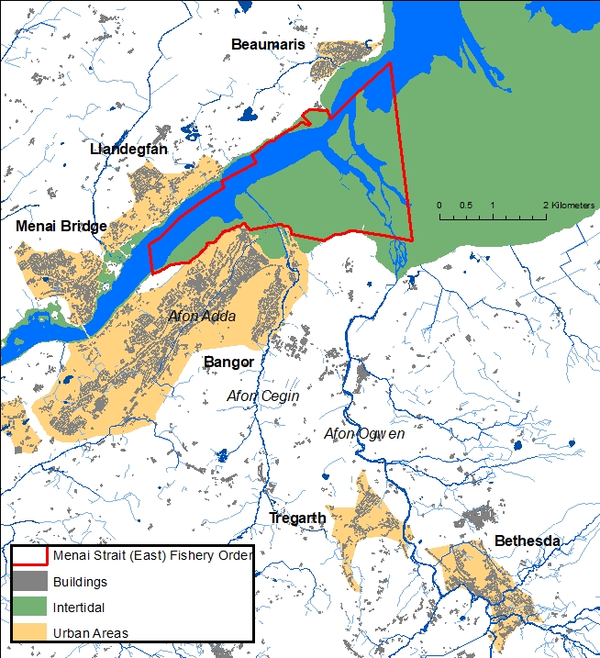
Figure 1.1. Map of the Fishery Order, main rivers, and urban areas. Contains OS Open data © Crown copyright and database right 2022

2. Methods

2.1 Sampling design

2.1.1 Routine sampling of shellfish, seawater & river water samples
Shellfish and seawater samples were collected by boat around high water, when the intertidal areas are accessible for sampling (and for commercial harvesting). The boat was provided and skippered by Deepdock Ltd. Shellfish were collected from the Representative Monitoring Points (RMPs) determined by the 2013 sanitary survey (Cefas, 2013), for 4 different mussel classification zones within the fishery (Table 2.1 and Figure 2.1). The production areas and RMPs studied were chosen in discussion with Deepdock Ltd. At each RMP a weighted stainless-steel cage (mesh 1”x1”), with a pick-up float, was regularly filled with 120 mussels (4 weeks of routine sampling). This allowed for the regular collection of mussels from the RMP precisely. Cages were restocked with mussels taken from the Menai East shellfish production area and were tested for E. coli and an array of viruses (e.g., CrAssphage, Adenoviruses, NoV GI, GII, Sapovirus, and Hepatitis A/E viruses) to quantify the relative loadings of each at the point of restocking. Restocking occurred a minimum of one week before any samples were taken. Official data for each of the RMPs was also explored (Cefas, 2022).
Seawater samples were taken in triplicate from 6 different shellfish waters monitoring points corresponding with the output locations of the Intertek-Dŵr Cymru Cynfyngedig model (Table 2.1 and Figure 2.1). Triplicate samples were also taken from the Afon Adda, Afon Cegin and Afon Ogwen, at locations corresponding with prior sampling conducted under the Menai Shellfish Water Storm Impact Assessment (Table 2.1 and Figure 2.1). The quantitative analytical methods used in this study are summarised in Table 2.3.

Table 2.1. Coordinates and number of samples processed for mussel and surface water sites
Sample Type | Site | Latitude | Longitude | Samples Processed
Mussels | Cegin Channel RMP | 53.23796 | -4.11898 | 29
 | Gallows Point RMP | 53.25329 | -4.10085 | 27
 | Ogwen Channel RMP | 53.23757 | -4.08494 | 28
 | West of Bangor Pier RMP | 53.23759 | -4.12420 | 29
Rivers | Afon Adda | 53.23459 | -4.11923 | 36
 | Afon Cegin | 53.23131 | -4.11093 | 37
 | Afon Ogwen | 53.21672 | -4.09491 | 38
Seawater | Beaumaris | 53.26270 | -4.08619 | 31
 | Cegin Channel | 53.23796 | -4.11898 | 31
 | Craig-Y-Don | 53.23547 | -4.14733 | 31
 | Gallows Point | 53.24405 | -4.12497 | 31
 | Gazelle | 53.25251 | -4.10441 | 32
 | Ogwen Channel | 53.24086 | -4.07903 | 29

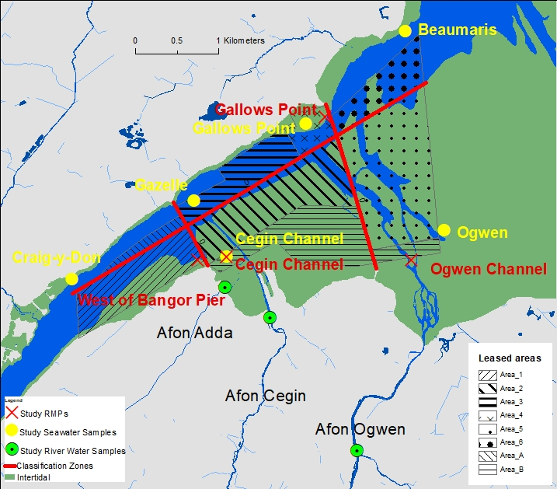
Figure 2.1. Map showing location of river water samples, seawater samples, RMPs and the division of the classification zones which they represent. Also shows individually leased areas. Contains OS Open data © Crown copyright and database right 2022

All rivers were sampled around low tide to ensure that the samples represented discharges from the river and not tidal water. This was important at the Afon Adda and Afon Cegin, where the sampling points are downstream of the tidal limit. All surface water samples were taken as advised by the Bathing Water Regulations (2013), including taking the sample from 30cm below the surface. Samples were taken in sterile translucent high-density polyethylene bottles (Nalgene) and stored in insulated boxes with cooling packs to maintain a storage temperature between 2°C and 10°C. Samples were stored at 4°C upon receipt at the laboratory until they were processed. All samples were processed within 24 hours of collection.

2.1.2 Environmental data collection
Rainfall data was taken from Natural Resources Wales’ Bethesda Quarry and Afon Adda rain gauges (Bethesda Quarry Rain Gauge, 2022; Afon Adda Rain Gauge, 2022; Appendix 5) and from the Ogwen Valley Mountain Rescue Organisation’s Automatic Weather Station (Vantage Pro, Davis Instruments), situated close to the watershed at 320 m.a.s.l. in the upland area of the catchment (Figure 2.2).
OTT Hydromet Ltd were contracted to commission a discharge logging system and CTD sonde (conductivity, temperature, depth) for the Afon Ogwen. The CTD (OTT CTD Sensor, OTT Hydromet) was installed at the mouth of the Afon Ogwen, below the tidal limit, logging data which will be valuable to coastal modelling activities including parallel Shellfish Centre project SC20, which investigates impacts of freshwater input on offshore water quality. Discharge sensing instrumentation was installed approximately 1.5 km upstream, at the same location as the Afon Ogwen river water sampling point. River discharge is estimated here using non-contact radar surface velocity sensing (SVR100, OTT Hydromet) and level sensing (RLS, OTT Hydromet) instruments, together with the results of a survey of the cross-sectional geometry of the channel (OTT Hydromet 2022). Velocity x Area Flow is calculated in the datalogger (OTT NetDL500) to give discharge values (Q m³/s). It was discovered, however, that flow in the channel becomes non-laminar at lower river levels, interfering with surface velocity measurement. This resulted in often poor-quality discharge data at low flows, but good quality discharge data during higher flow events. During periods of higher flow, microbial flux from the Afon Ogwen was estimated using discharge and concentration data. Level measurement was always reliable and was used to indicate the river’s state outside of high flow events.
Samples were subject to environmental marker, nutrient and microbiological contaminant analyses (Table 2.2) All water samples were analysed for turbidity (Oakton T-100 Turbidity meter) and salinity (HI-98319 marine salinity tester). Nutrient concentrations (Total Oxidised Nitrogen, Nitrite, Phosphate and Ammonia) were determined using a segmented flow colorimetric analyser (SEAL Analytical AA3 HR), following the manufacturer’s procedures.

Table 2.2 Summary of analytical methods used in this study
Assay | Sample type | Data Output
MPN, Pour Plate, Impedance | Mussels | E. coli CFU or MPN/100g shellfish flesh.
qPCR | Mussels | NoV (GI, GII), Adenoviruses, Hepatitis, CrAssphage, MS2, MNV Viruses genome copies (gc)/g shellfish digestive tissue
 | River water and seawater
Membrane Filtration | River water and seawater | E. coli/100 ml
Nutrient Analysis | River water and seawater | Total oxidized nitrogen, Nitrite Silicate, Phosphate, Ammonia
Environmental Markers (i.e., Turbidity, Salinity) | River water and seawater | NTU, PSU

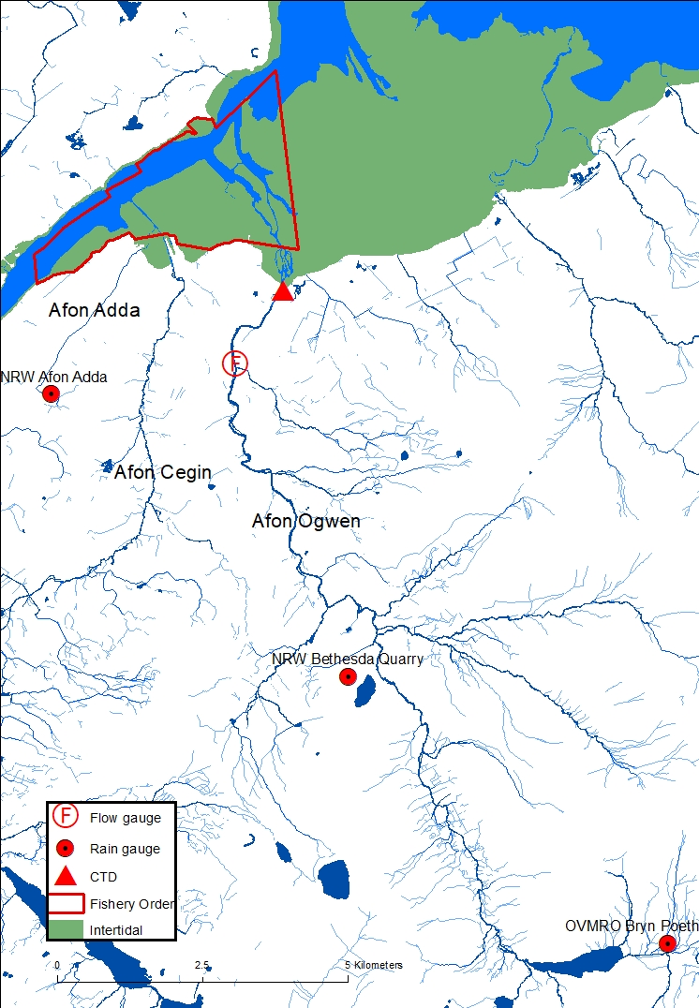
Figure 2.2. Location of hydrometric instrumentation, river catchments and the Fishery Order.

2.1.3 Event sampling
We sampled river water, seawater, and shellfish at selected routine sampling points more frequently during three separate rainfall events. This enabled us to investigate the relationship between rainfall events and sample E. coli and virus concentrations at higher temporal resolution. River E. coli flux was calculated for time points when river discharge data passed quality control. When river discharge data were of poor quality, river level was used to indicate the river state. We investigated NoV (GI, GII) levels in effluent at Treborth WwTW when data were available, to indicate local prevalence.
Portable, refrigerated autosamplers (Avalanche, Teledyne ISCO) were used to collect high frequency river water samples during events I and II. These contained 14 x 950 ml bottles and were configured for start time, sampling frequency, sample volume and composite or discrete sampling. Autosampler bottles and tubing were disinfected before each deployment and lines were purged automatically between samples. Avalanche autosamplers cool the refrigerated compartment to 1°C ±1 during a programme run and this setting cannot be changed. This condition could trigger a ‘viable but nonculturable’ (VBNC) state in E. coli (Oliver, 2010). This could result in the underestimation of E. coli concentration in these samples. However, the sample E. coli concentrations derived for triplicate Afon Adda, Afon Cegin, and Afon Ogwen processed immediately or after 24 hours in the autosampler at 1°C ±1 were similar (data not shown). After programme end, Avalanche autosamplers maintain samples at 3°C, ±1 and this setting was left as default. These samples were retrieved within 12 hours of the last sample collection, stored at 4 °C in the laboratory and processed within 24 hours of the sample collection time. E. coli was quantified in discrete water samples using membrane-filtration (2.4). Then samples were pooled to composite volumes sufficient for viral recovery by skimmed milk flocculation (2.4.1). Shellfish were collected at low and/or high tide during events (on foot / by boat). E. coli was quantified in shellfish using MPN (2.2.1), pour plate (2.2.2) and impedance (2.2.3) methods. Viruses were extracted from digestive tissues (2.4.2) and quantified using qPCR (2.4.7). Events sampling conditions are summarised in Table 2.3.

Table 2.3. Summary of Event Sampling Conditions.
 | Event I | Event II | Event III
Date | 17/05/22 – 19/05/22 | 28/06/22 – 29/06/22 | 26/09/22 – 03/10/22
Duration | 3 days | 2 days | 8 days
Rivers Sampled | Afon Ogwen | Afon Ogwen | Afon Ogwen  Afon Cegin  Afon Adda
Sampling Method | Autosampler | Triplicate Autosampler | Triplicate Manual
Sampling Frequency | 1 hr, 950 ml  Discrete, sequential | 30 m, 230 ml  Composite, 4 samples / bottle | Daily, 1000 ml  (except 02/10/22)
Analysis | E. coli and Viruses | E. coli | E. coli and viruses
Sea Waters Sampled | - | - | Ogwen  Beaumaris  Cegin Channel  Gallows Point  Gazelle  Craig-y-Don
Sampling Events | - | - | HW 28/09/22  HW 03/10/22
Analysis |  |  | E. coli and viruses
Mussels Sampled | Ogwen Channel RMP | - | Ogwen Channel RMP  Cegin Channel RMP  West of Bangor Pier RMP  Gallows Point RMP
Sampling Events | LW 17/05/22  LW 18/05/22  HW 19/05/22 | - | HW 28/09/22  HW 03/02/22  And LW daily at Cegin Channel and West of Bangor Pier RMPs
Analysis | E. coli and Viruses. |  | E. coli and viruses

2.1.4. Passive sampling
We deployed tampons as passive sampler collection swabs to indicate the viral load passing through the Afon Ogwen during event III (2.1.3). Tampons have previously been used as passive samplers due to their high affinity for viruses over a long time period (Li et al., 2022; Kevill et al., 2022; Vincent-Hubert et al., 2021). Each passive sampler unit comprised a Tampax Super Compak Tampon (Procter & Gamble) enclosed in a sterile plastic 50 ml syringe casing. Holes were drilled in the casing to expose the tampon to saturation with river water. Passive samplers were tethered to nylon rope weighted with metal chain to secure the unit in position. Passive samplers were deployed in triplicate at the routine Afon Ogwen sampling point (Table 2.1 and Figure 2.2). Water and virus absorption by tampons is non-linear, until viral saturation after 6-8 hours in wastewater (Kevill et al., 2022; Bivins et al., 2022a). Deployment durations were between 24 and 48 hours.
On collection, tampons were removed from syringes, transferred to sterile plastic zip lock bags and transported to a refrigerator (4°C) within 15 minutes. Samples were processed within 24 hours. Each of the tampons was manually massaged through the bag to elute viruses with the liquid (Bivins et al., 2022b). A hole was cut in the corner of each zip lock bag to aseptically transfer the liquid to a sterile 50 ml centrifuge tube (resulting in ~20 ml of liquid). For each sample, total volume was adjusted to 30 ml using sterile phosphate-buffered saline (PBS) pH 7.4. Each sample was spiked with 20 μL murine norovirus (MNV) culture as a recovery control. Next, 10 ml of PEG-NaCl Solution (40% PEG8000 (400g/L) and 8% NaCl (80g/L)) was added to each sample. Samples were incubated for 16 hours at 4 °C then centrifuged at 10,000 x g for 30 minutes at 4 °C (Sigma 6-16KS centrifuge). The supernatant was discarded without disturbing the pellet, which was resuspended in 500 μL PBS. Resulting samples were extracted immediately or frozen at -80 °C before nucleic acid extraction (2.4.6) and virus quantification by qPCR (2.4.7).

2.2 E. coli quantification in shellfish
We compared three methods for the quantification of E. coli concentration in shellfish. Each mussel sample was processed by parallel MPN, pour plate and impedance methods. Samples were prepared in accordance with the MPN method (ISO 16649-3), but we made an initial 1:1 dilution for the pour plate method (ISO 16649-2). Further dilutions of the same homogenate were made for the MPN and impedance (NF V08-106) methods (See Figure 2.3).

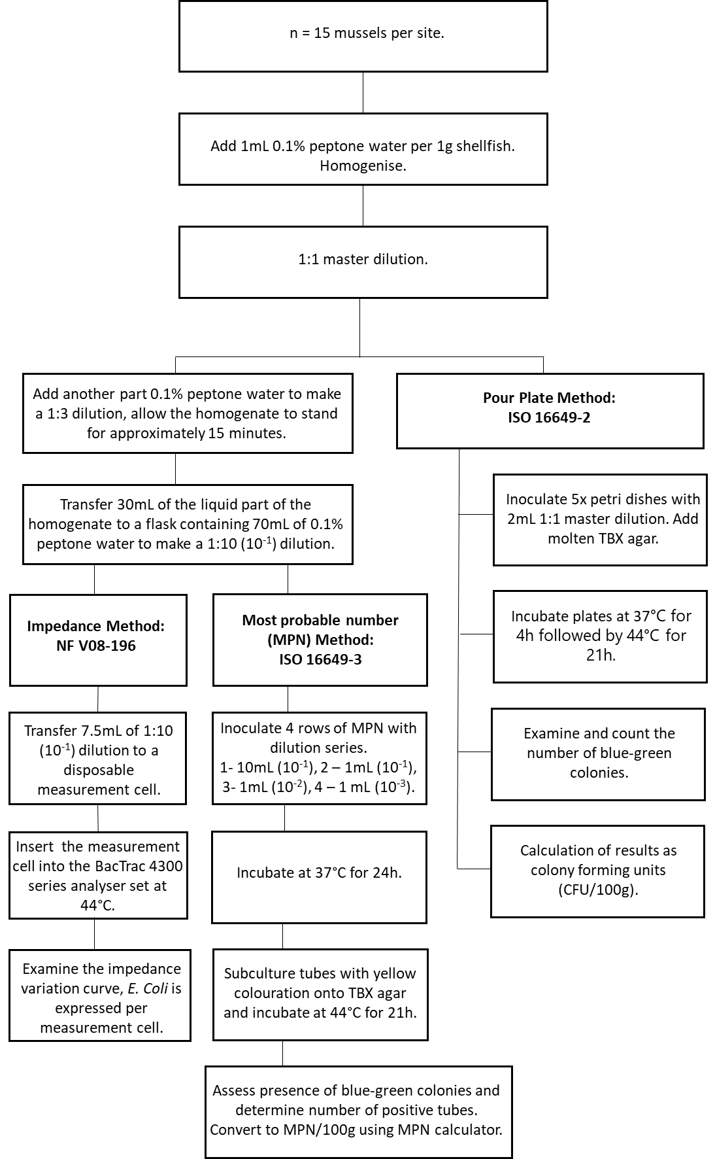
Figure 2.3. Flow chart summarising the laboratory process for parallel MPN, pour plate and impedance methods for the quantification of E. coli from one shellfish sample.

2.2.1 Dilution tube MPN method
The method is described (ISO 16649-3). Briefly, each sample dilution (10⁻¹, 10⁻² and 10⁻³) was inoculated into one row of 5 tubes containing either double- (row 1) or single strength (rows 2-4) minerals modified glutamate broth (MMGB) before incubation at 37±1°C for 24±2 hours. After incubation, MPN tubes were examined for yellow colouration indicating E. coli positivity. E. coli presence was confirmed by subculture on Tryptone Bile X-Glucuronide (TBX) agar at 44±1°C for 21±3 hours. Blue/green colonies confirmed the presence of E. coli. The number of positive tubes at each dilution was used to calculate the Most Probable Number of E. coli per 100 g of the shellfish sample and confidence intervals (Jarvis et al., 2010). Uninoculated tubes of 10±0.2 ml single strength and 10±0.2 ml double strength MMGB were included in all assays as negative controls.

2.2.2 Pour plate method
The method is described (ISO 16649-2). Briefly, 2 ml of 1:1 dilution shellfish sample and 18 ml molten TBX agar was added to each of 5 sterile petri dishes, gently mixed, and incubated at 37±1°C for 4 hours then 44±1°C for a further 21±3 hours. The number of blue/green colonies was used to calculate E. coli Colony Forming Units (CFU) per 100g shellfish sample:
CFU/100g = ((∑c /V) x tv) *100
∑c is the sum of blue/green colonies across all 5 plates, V is the total volume of the inoculum across the 5 dishes (10 ml) and tv is the total volume of the sample added to each plate (2 ml).

2.2.3 Impedance method
The method is described (NF V08-106). It has been calibrated and validated against the MPN method in compliance with the standards of ISO 16140 (Dupont et al., 2009; 2011). Briefly, 7.5 ml (±0.15 ml) of 10⁻¹ sample dilution was transferred into a disposable cell membrane (AmpMedia 003, 62-100323) and loaded into the Bactrac 4300 Microbiological Impedance Analyser (SY-LAB, Neupurkersdorf, Austria). The instrument measured the impedance curve over 5-10hr at 44±0.5°C and software predicted the number of E. coli per 100 g shellfish sample from that curve.

2.3 E. coli quantification in water
E. coli was quantified in river and water samples by membrane filtration and culture on chromogenic coliform agar (CCA) (ISO 9308-1:2014). For seawater samples 500 ml and 100 ml sample volumes, and for river samples 10ml, 1ml and 0.1ml sample volumes, were filtered through cellulose nitrate filters (Sartorius, 47mm diameter, 0.45µm pore size). A small volume of sterile 0.1% peptone water was added to filters prior to filtering 1ml and 0.1ml river samples, to allow the bacteria to spread across the filter. Once the water had filtered, membrane filters were individually placed on Chromogenic Coliform Agar. Plates were inverted and incubated at 37 °C. After 22 hours, dark blue - violet E. coli colonies were counted. E. coli counts of 10-100 colonies per plate were considered reliable, hence the use of multiple dilutions.

2.4 Virus quantification

2.4.1 Virus concentration from water
The volume of water samples taken for virus quantification was 10 L. Samples were stored at 4°C for up to 24 hours before processing. Viruses were concentrated from water samples using the skimmed milk flocculation method (Calgua et al., 2013). Briefly, sample conductivity was adjusted to 1.5mS with artificial seawater powder. The pH of the samples was adjusted to 3.5 using 1 M HCl. A 1% skimmed milk-in-artificial seawater (pH 3.5) solution was added to achieve 0.01% concentration. Samples were stirred for 8 hours and then settled for 8 hours. The supernatant was removed with a vacuum pump until 200-500 ml remained. The concentrate was centrifuged at 10,000 x g for 30 minutes at 4 °C. The resulting pellet was resuspended in 1-10 ml phosphate saline buffer (PBS, pH 7.4). The sample was stored briefly at +4°C, or at -80 °C before nucleic acid extraction (2.4.6).

2.4.2 Virus extraction from shellfish for quantification
Mussel samples were processed according to ISO 15216-2:2019. Briefly, 15 mussels per sample were shucked and digestive tissues dissected and pooled. Two-gram aliquots of homogenised digestive tissue were spiked with MNV then agitated 320 rpm in proteinase K at 37°C for 1 hour. The Proteinase K was inactivated at 60°C and the sample was centrifuged at 3000 rpm for 5 minutes. The supernatant was stored briefly at +4°C, or at -80°C before nucleic acid extraction (2.4.6).

2.4.3 Virus extraction from shellfish for infectivity assays
Virus infectivity and/or capsid-integrity assays were carried out for thirteen samples. The method of extraction was informed by Barardi et al., (1999) and Polo et al., (2018). Briefly, 2g samples of digestive tissue were mixed with an equal amount of PBS and sonicated for 30 s. Each sample was mixed with 2 ml chloroform and butanol (3:1), vortexed for 30 s and mixed with Cat-Floc to 0.83%. The mixture was incubated at room temperature for 5 min. After centrifugation at 10,000 x g for 20 min at +4°C the supernatant was removed, and its volume adjusted to 6.5ml with PBS (pH 7.4). The eluent was mixed with polyethylene glycol (PEG) 8000 and with NaCl to reach a final concentration of 10% and 2%, respectively. The mixture was incubated at +4°C for 16 hours and centrifuged at 14,000 x g for 15 min at +4°C. The resulting pellet was dissolved in Dulbecco's Modified Eagle Medium (DMEM), sonicated for 30 s and centrifuged at 2,862 x g for 15 min at 4°C. The supernatant was filtered through a 0.22µm polyethersulfone (PES) filter then concentrated using an ultra-centrifugal filtration unit (Amicon-15 100k, Merck, Germany).

2.4.4 Virus integrity assay
The NoV capsid integrity assay using porcine gastrin mucin-coated magnetic beads (PGM-MBs) has been described for environmental waters (Farkas et al., 2018). It was modified to attempt to determine the integrity of NoV in environmental shellfish samples. Briefly, a 0.5 ml aliquot of the shellfish virus samples concentrated in 2.4.3 was mixed with 20µl PGM-MBs for 30 min. The PGM-MBs were separated using magnetic force and washed and resuspended with PBS. The samples were incubated at 96°C for 10 min then the PGM-MBs were removed with magnetic force. Nucleic acids were extracted from the solution (2.4.6).

2.4.5 Virus culture
Adenoviruses were cultured using an integrated cell culture qPCR (ICC-qPCR) method described by Ogorzaly et al., (2013). Briefly, Cell line 293A (Invitrogen, USA) was cultured in high-glucose DMEM, supplemented with 1% of non-essential amino acids (Life Technologies, USA) and 5% of foetal bovine serum (FBS; Life Technologies, USA) to reach 80% confluency. A 1 ml aliquot of the selected samples was added to the cells and incubated at 37°C for 1 hour to allow adsorption of the virus particles. The cells were washed with DMEM and eluted in 4ml of DMEM supplemented with 2% FBS and 1% antibiotics–antimycotic solution (Life Technologies, USA). Nucleic acids were extracted from the solution upon setup (2.4.6), and again after two days of incubation at 37°C.

2.4.6 Virus nucleic acid extraction
Viral nucleic acids were extracted using the NucliSens miniMAG and NucliSens magnetic extraction reagents (bioMérieux) following the manufacturer’s instructions.

2.4.7 Virus quantitative PCR
Two different triplex, Reverse-Transcription, quantitative, Polymerase Chain Reaction (RT-qPCR) assays were used to quantify the RNA of NoV (GI, GII), sapovirus and hepatitis A and E viruses, as previously described (Farkas et al., 2017). A duplex qPCR was used to quantify the DNA of human mastadenovirus F and animal Atadenovirus, and a separate singleplex qPCR was used for crAssphage (Farkas et al., 2019, Wolf et al., 2010). We used a QuantStudio 6 Flex instrument (Applied Biosystems, USA). Kits and all primers and probes used are listed in Appendix 6. For every plate, negative controls were included, and sample amplification curves were compared with standard curves for five 10-fold serial dilutions (10⁵ to 1 copy/ µl). QuantStudio real-time PCR software V1.7 (Applied Biosystems, USA) was used to analyse the real-time data. Genome copies (gc) / µl extract were converted to gc/100ml water or gc/g shellfish digestive tissue as:

$$\frac{\left(Quantity mean x RNA eluent\right)}{Extraction volume}x \frac{Concentrate volume }{Total volume }$$

2.4.8 Quality control
We quantified the recovery of spiked MNV as a process control. We adopted the ISO 15216- 2:2019 standard for efficiency >1%.
$$\frac{Sample eluent concentration}{Control eluent concentration}x100\%$$

2.5 Statistical analysis

2.5.1 Comparisons of sites by crAssphage concentration
To assess whether there was a significant difference between crAssphage concentrations in samples from the Afon Adda, Afon Cegin and Afon Ogwen, a Repeated Measures Analysis of Variance (RM-ANOVA) was used. RM-ANOVA was also used to assess whether significant differences in crAssphage concentrations were observed between the four shellfish RMP’s. Post-hoc pairwise t-test comparisons with Bonferroni adjustment were used to assess where any significant differences exist.

2.5.2 Correlation matrices
Spearman’s rank correlations were used to assess the relationship between MPN and Pour Plate E. coli concentrations and viral indicators- human mastadenovirus F (AdVF), crAssphage (CrAss), and NoV (GI, GII) in mussels collected from the RMPs. Spearman’s rank correlations were also used to assess the relationship between river water E. coli concentrations, viral indicator human mastadenovirus F (AdVF), crAssphage (CrAss), NoV (GI, GII) concentrations and turbidity. The Cegin Channel seawater site, where 10L seawater virus samples were also collected, was assessed similarly.
Relationships between nutrient concentrations (NOx: nitrite + nitrate, NO₂: nitrite, PO₄: Phosphate, NH₃: Ammonia), turbidity and the concentrations of E. coli and viral indicators in all surface waters were also assessed via Spearman’s rank correlations. A final matrix comprising Spearman’s rank correlations was produced to assess the relationships between E. coli concentrations at the different shellfish RMPs.

2.5.3 Sources of E. coli
A range of statistical techniques were used to better understand the differences in the concentrations of E. coli in the inputs to the Menai East area, with a view to identifying which potential sources of faecal pollution might drive E. coli concentrations in the mussels at the RMPs. We intended to inform our modelling with Combined Sewer Overflow Event Duration Monitoring (CSO EDM) data because these discharges may be strong predictors of E. coli contamination at the RMPs. These data were not available at the time of writing but will be included in future updates to the modelling analysis. To assess whether there was a significant difference between E. coli concentrations measured in the Afon Adda, Afon Cegin and Afon Ogwen, RM-ANOVA was used. A post-hoc pairwise t-test with a Bonferroni adjustment comparison was also used to assess where differences between the rivers might exist.
A stepwise regression was executed using rainfall data from the Bethesda Quarry rain gauge and river level data for the Afon Ogwen as possible predictors of E. coli concentrations in mussels at the RMPs. Lagged rainfall and river level data (1 day) was also included in the stepwise regression because there might be a delay between rainfall and faecal contamination arriving at the RMPs. The stepAIC routine in R was used for the stepwise regression, with forwards and backwards selection selected.
The relationship between the E. coli concentrations in the rivers and the shellfish RMPs was then explored using multiple linear regressions using the environmental predictors selected by the stepwise regression. The mediation of the response of the shellfish RMPs to the influence of the E. coli concentrations in the three rivers by the environmental predictors selected by the stepwise regression was also explored. It should be noted that depending on tidal state on a given sampling day, river samples were either collected before or after the collection of shellfish. It is possible that the collection of river samples after the collection of shellfish samples might have influenced the results of these investigations. Ideally, all river samples would have been collected during the low tide before the sampling of the RMP. However, this was not feasible.
All parallel MPN and pour plate data for shellfish samples, including samples taken during targeted rain events, were utilised in the comparisons between the methods used to enumerate E. coli in shellfish. To assess whether the pour plate or MPN methods reported E. coli concentrations that were significantly different a pairwise t-test was used. Following this a Bland-Altman plot was produced to allow for a visual inspection of how the differences in concentration reported by the two methods change with the mean magnitude of the E. coli concentrations reported by both methods. Data under the limits of quantification (LOQ) are not reliable and generally treated as estimates scored at 0.5x the LOQ (LOQ = 200 CFU/100g for the pour plate method). However, when results are frequently <LOQ, treating all these values as 0.5x the LOQ will skew the data for statistical analysis. Whilst all RMPs included in this study were class B classified, many of the E. coli concentrations were below the limit of quantification for the pour plate method. The minimum possible values differ between the two methods. Analyses were therefore presented with and without 0.5x scoring for data below the LOQ. The relative frequencies of the results that fell within classification thresholds were calculated for both methods to understand how the application of the pour plate method over a 10-month period of high frequency sampling would compare to the MPN method.

3. Results

3.1 Spatio-temporal surveillance of viruses

3.1.1 Viral abundance and contamination source tracking
NoV GI and GII were detected in all sample types, but NoV GI was absent from mussel samples taken at the Ogwen Channel and in seawater samples from the Cegin Channel (Figure 3.1, Figure 3.2). In general, NoV GII genotype was detected as often or more frequently than GI in all sample types and all locations, except in the Afon Ogwen samples (Table 3.1). NoVs were more frequently detected in river water samples than in mussels. Peaks in NoV abundances were observed during March-May and September-October 2022. However, viral concentrations were still close to or below the theoretical limit of detection (LOD). The other human enteric RNA viruses targeted, namely hepatitis A and E viruses and sapoviruses, were not detected in any of the samples.

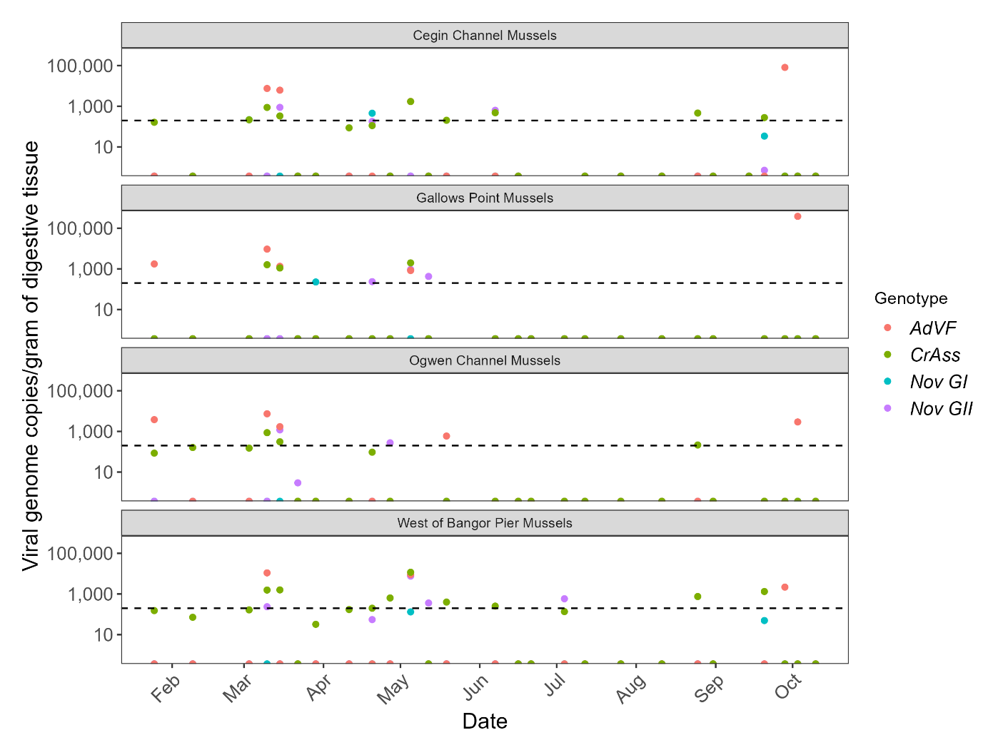Figure 3.1. Viral genome copies (gc) human mastadenovirus F (AdVF), crAssphage (CrAss) and NoV GI and GII in shellfish digestive tissue of mussels taken from the shellfish RMPs between January – October 2022. The dotted line indicates the limit of detection (200 gc/g). Note the log scale of the y axis.

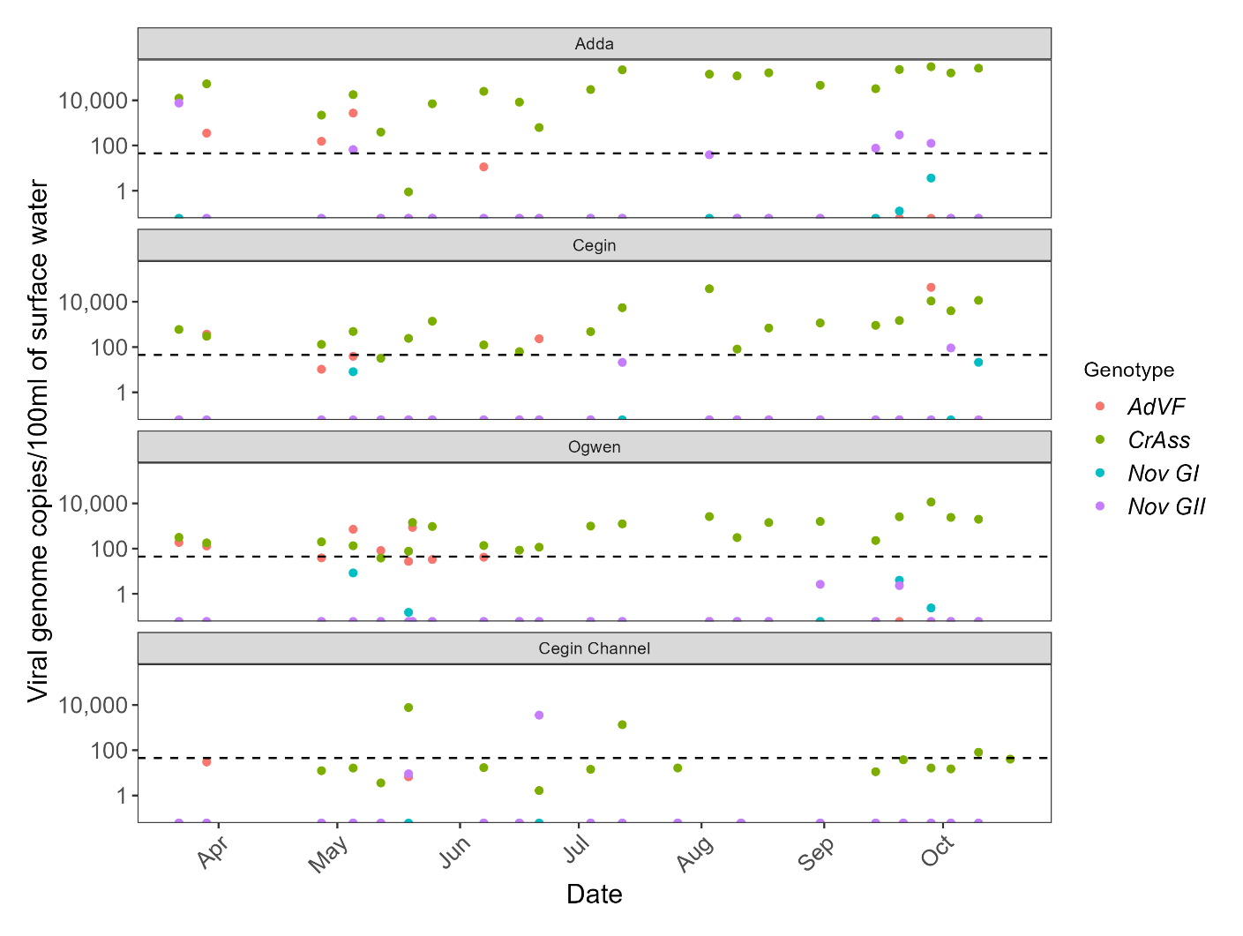Figure 3.2. Viral genome copies (gc) of human mastadenovirus F (AdVF), crAssphage (CrAss) and NoV GI and GII in river water at the Afon Adda, Afon Cegin, Afon Ogwen, and sea water at the Cegin Channel (situated at the shellfish RMP) between March – October 2022. The dotted line indicates the limit of detection for all viruses (44.8 gc/100ml). Note the log scale of the y axis.

Table 3.1. Virus detection rates in mussel and water samples between March – October 2022. The numbers in brackets represent the number of samples testing positive for the target virus.
Sample | n | Human NoV GI | Human NoV GII | Human mastadenovirus F | Atadenovirus  (Sheep, cattle, deer, goats) | CrAssphage (human gut)
Cegin Channel mussels | 25 | 12% (3) | 16% (4) | 16% (4) | 0% | 44% (11)
Gallows Point mussels | 25 | 4% (1) | 12% (3) | 20% (5) | 0% | 12% (3)
Ogwen Channel mussels | 24 | 0% | 12.5% (3) | 20.8% (5) | 0% | 29.2% (7)
West of Bangor Pier mussels | 26 | 7.7% (2) | 19.2% (5) | 11.5% (3) | 0% | 57.7% (15)
Afon Adda | 21 | 14.3% (3) | 28.6% (6) | 19% (4) | 0% | 100% (21)
Afon Cegin | 21 | 9.5% (2) | 9.5% (2) | 23.8% (5) | 0% | 95.2% (20)
Afon Ogwen | 21 | 19% (4) | 9.5% (2) | 43.9% (9) | 4.8% (1) | 100% (21)
Cegin Channel (surface seawater) | 19 | 0% | 10.5% (2) | 10.5% (2) | 0% | 66.7% (14)

Human mastadenovirus F and crAssphage viruses were detected in shellfish and surface water samples, being present at all locations on occasions during the sampling period (Figure 3.1, Figure 3.2). The prevalence of mastadenovirus F was similar within shellfish and surface waters and was primarily detected in spring and early summer. Surface seawater samples taken from the Cegin Channel showed low detection of mastadenovirus F in comparison to surface water river samples taken from the Afon Adda, Afon Cegin, and Afon Ogwen. The virus was most frequently detected in the Afon Ogwen samples with considerably higher detection rates observed than at the other sampling sites (Table 3.1). In contrast, Atadenovirus (infecting mainly cattle and sheep) was found in only one sample, taken at the Afon Ogwen (208 gc/100ml).
Human gut-associated crAssphage was the most prevalent virus, detected at high frequencies throughout the year in all sample types and locations. Cegin Channel and West of Bangor Pier RMPs had the highest prevalence of crAssphage detection (44% and 57.7% of total samples) within shellfish samples (196.4 ± 76.1 gc/g, and 741 ± 452.3 gc/g respectively) where they were detected throughout the sampling period, this temporal and spatial prevalence may be associated with their proximity to the City of Bangor (Figure 3.1, Figure 3.3). Gallows point mussels had the lowest frequency of crAssphage prevalence but showed high concentrations when present (186.17 ± 105.89 gc/g), and only during the months of March and early May (Figure 3.1, Figure 3.3). CrAssphage detected at the Ogwen RMP displayed the lowest overall gc/g concentrations (78.71 ± 38.43 gc/g). A repeated measures ANOVA was used to assess differences in the concentration of crAssphage at the four shellfish RMP’s. A significant difference between the log10 transformed crAssphage gc/g concentrations was detected between the four shellfish RMP’s (Repeated Measures ANOVA: F_{3, 60} = 8.612, p < 0.001). A post-hoc pairwise t test with a Bonferroni adjustment comparison showed that Gallows Point displayed significantly lower crAssphage gc/g concentrations compared to the West of Bangor Pier RMP (p = < 0.01). However, no other significant differences were detected between the remaining RMPs (Figure 3.3).

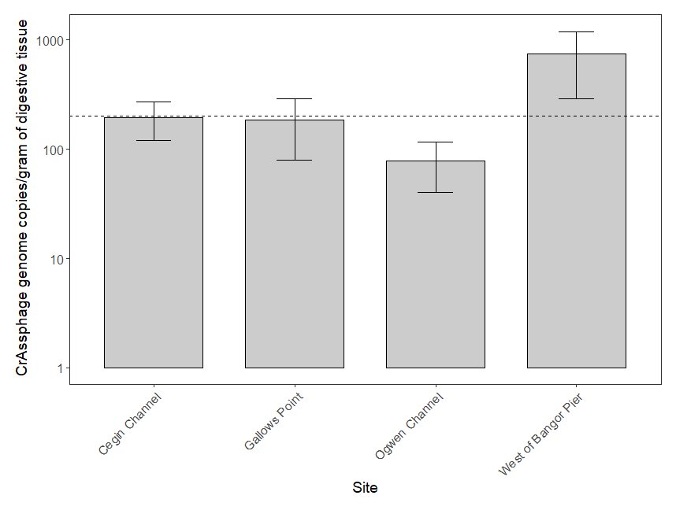Figure 3.3. Quantities (mean ± SE) of crAssphage gc/g detected at the four shellfish RMPs between January – October 2022. The dotted line indicates the limit of detection (200 gc/g). Note the log scale of the y axis.

CrAssphage was detected in almost all water samples taken from the Afon Adda, Afon Cegin and Afon Ogwen (95.2-100% detection rate, Table 3.1). CrAssphage concentrations were consistently higher at the Afon Adda (87,317 ± 21,623 gc/100ml), compared to the Afon Cegin and Afon Ogwen (3716 ± 1857, 1387 ± 528 gc/100ml, respectively). However, the overall temporal prevalence and detection of crAssphage was similar among the river water samples (Figure 3.4). Similar to human mastadenovirus F, lower crAssphage detection rates were observed at the Cegin Channel seawater site compared to the river samples, probably due to dilution (Table 3.1). A repeated measures ANOVA was used to assess differences in the concentration of crAssphage between the Afon Adda, Afon Cegin and Afon Ogwen. A significant difference between the log10 transformed crAssphage gc/100ml concentrations was detected between the three river sites (Repeated Measures ANOVA: F_{1.53, 30.61} = 39.4, p < 0.001). A post-hoc pairwise t test with a Bonferroni adjustment comparison showed that the Afon Adda had significantly higher concentrations of crAssphage than both the Afon Cegin (p = < 0.001) and Afon Ogwen (p = < 0.001). There was no significant difference detected between the Afon Ogwen and Afon Cegin (Figure 3.4).

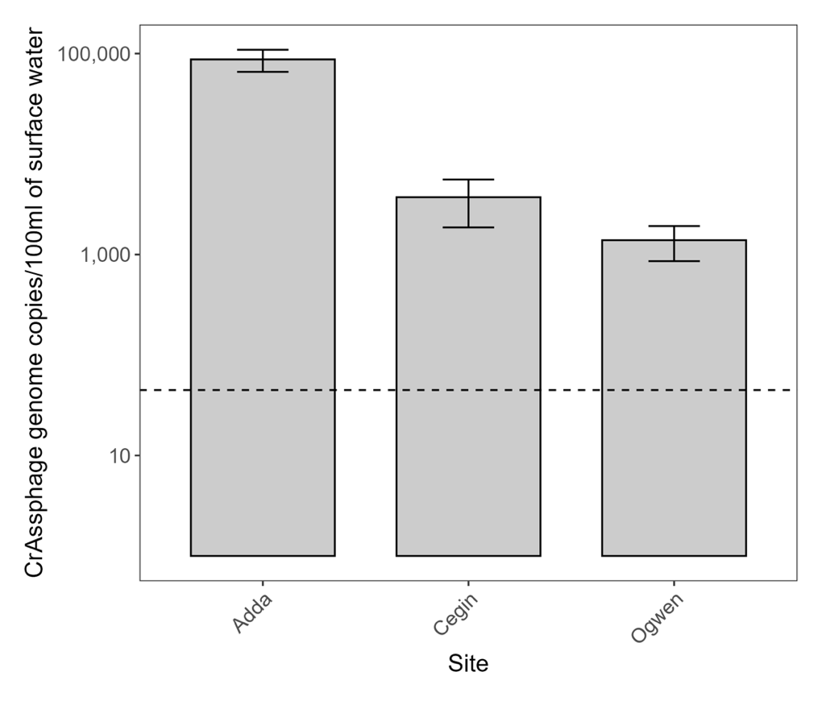
Figure 3.4. Quantities (mean ± SE) of crAssphage gc/100ml detected at the Afon Adda, Afon Cegin, and Afon Ogwen between January – October 2022. The dotted line indicates the limit of detection (44.8 gc/g). Note the log scale of the y axis.

3.1.2 Virus integrity and infectivity
None of the 13 shellfish samples were positive for intact NoVs or infectious adenoviruses using integrity and culturing-based assays, respectively.

3.1.3 Correlation between faecal indicators, human viruses, and environmental markers
We aimed to explore the relationship between environmental markers and concentrations of E. coli and viruses in environmental samples. Some targets are frequently not present, or present at levels <LOQ or <LOD of the respective methodology. Correlations may be genuinely very weak but in datasets with high frequency <LOQ data this can further weaken apparent relationships. We report the correlations which we consider valid.
Spearman’s rank analysis was conducted for targets in mussels at the RMPs (Figure 3.5). Some significant correlations were found. The strongest correlation was between human mastadenovirus F and human gut-associated crAssphage (r_{s} = 0.35, p < 0.01). Microbial concentrations of E. coli concentration by the MPN and Pour Plate method correlated weakly (r_{s} = 0.32, p < 0.01). E. coli by MPN and pour plate both correlated weakly with mastadenovirus F (r_{s} = 0.34, p < 0.01; r_{s} = 0.20 p < 0.05, respectively). E. coli detected by the MPN method also correlated weakly with crAssphage (r_{s} = 0.29 p < 0.01). CrAssphage correlated weakly with both NoV genotypes (GI: r_{s} = 0.26, p = 0.01; G2: r_{s} = 0.30, p < 0.01). Mastadenovirus F was only significantly correlated with NoV GII (r_{s} = 0.20, p < 0.05). NoV GI, GII were weakly correlated (r_{s} = 0.23, p < 0.05). The low strength of some correlation coefficients may be partially explained by the high frequency of scored (<LOQ) and not-detected results in the dataset.

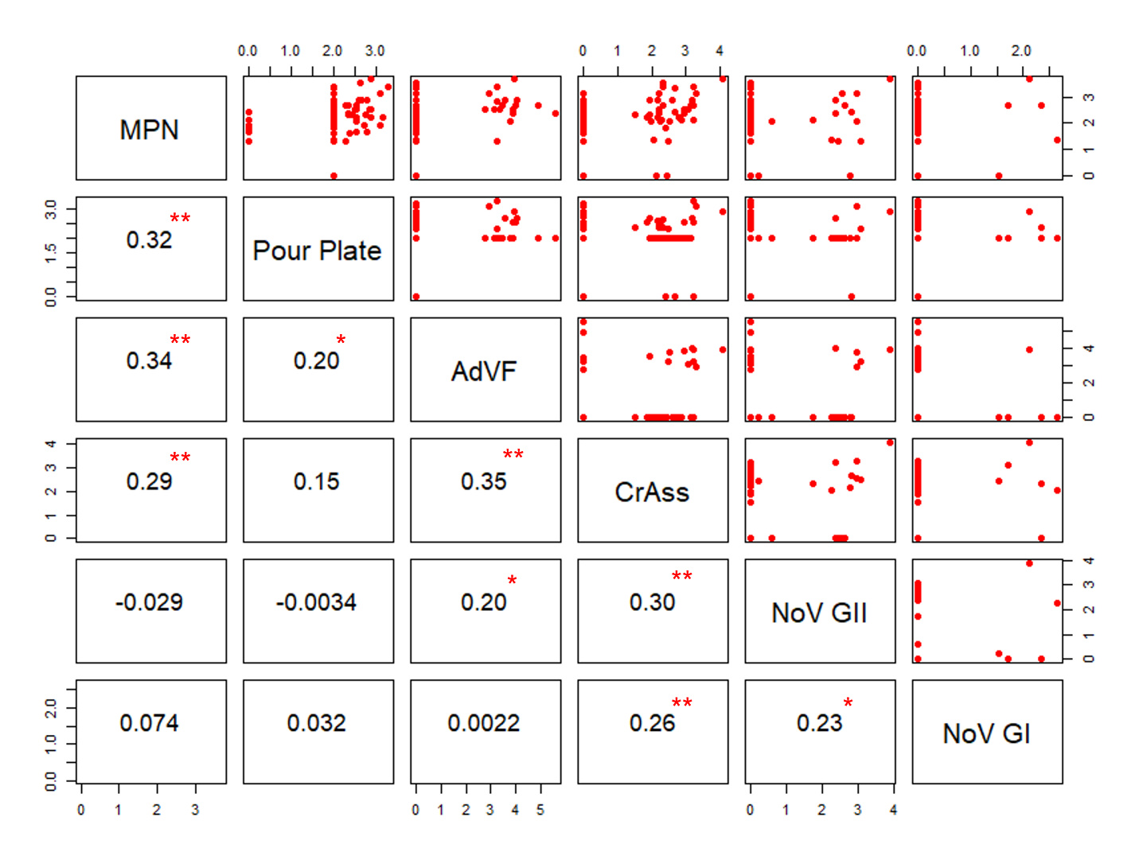Figure 3.5. Paired plots and Spearman’s rank correlation coefficient values between microbial concentrations (MPN and Pour Plate (CFU/100g) E. coli), turbidity (NTU), and viral indicator concentrations (gc/g)- human mastadenovirus F (AdVF), crAssphage (CrAss) and NoV GI and GII in mussels collected from the four RMPs. Log 10 x+1 transformed data. The red asterisks indicate a significant correlation coefficient (p < 0.001 [***]; p < 0.01 [**]; p < 0.05 [*]).

In river water samples, crAssphage correlations with turbidity and with E. coli concentrations were of moderate strength (r_{s} = 0.44, p < 0.01; r_{s} = 0.45, p < 0.01, respectively). CrAssphage concentrations also correlated with NoV GII (r_{s} = 0.41, p < 0.01) but not GI. NoV genotypes (GI, GII) were weakly correlated (r_{s} = 0.31, p = 0.01). Evidence of faecal pollution derived from animal sources was minimal, with low detection rates of Atadenovirus (Table 3.1).

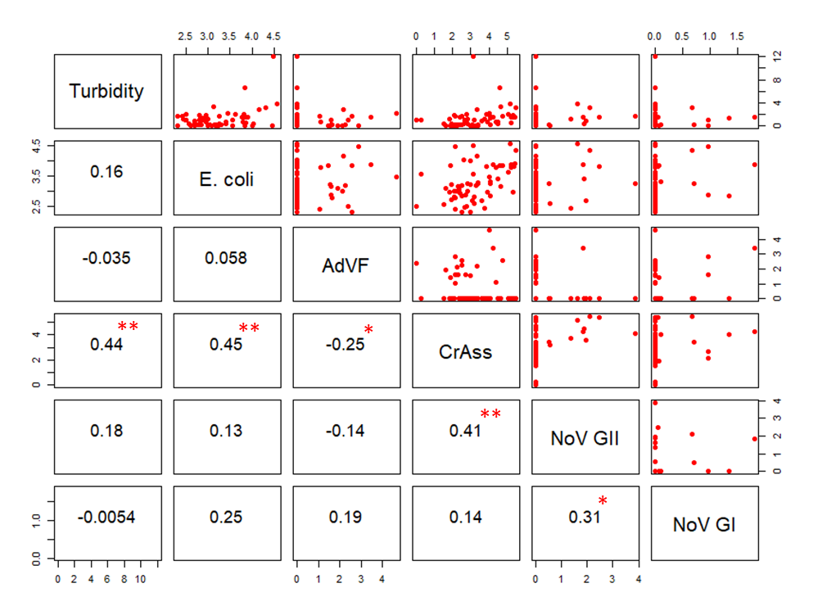Figure 3.6. Paired plots and Spearman’s rank correlation coefficient values between microbial concentrations (E. coli CFU/100ml), turbidity (NTU), and viral indicator concentrations (gc/g)- human mastadenovirus F (AdVF), crAssphage (CrAss) and NoVGI and GII at the Afon Adda, Afon Cegin and Afon Ogwen. E. coli and viral concentrations represent log 10 x+1 transformed data. The red asterisks indicate a significant correlation coefficient (p < 0.001 [***]; p < 0.01 [**]; p < 0.05 [*]).

A significant negative correlation was detected between microbial concentrations of E. coli and turbidity within the Cegin Channel surface seawater samples (r_{s} = -0.50, p < 0.05) (Figure 3.7).

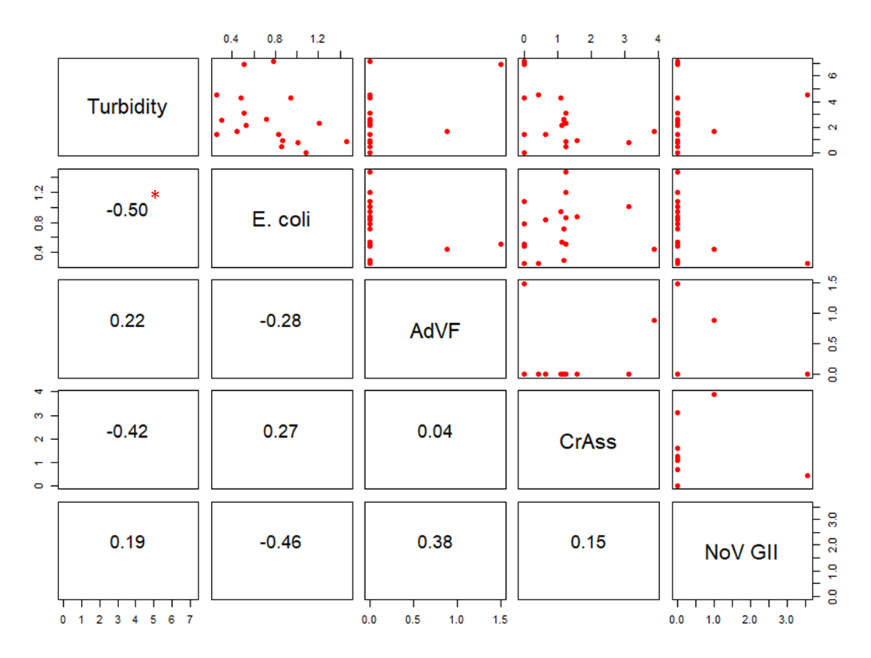Figure 3.7. Paired plots and Spearman’s rank correlation coefficient values between microbial concentrations (E. coli CFU/100ml), turbidity (NTU), and viral indicator concentrations (gc/g)- human mastadenovirus F (AdVF), crAssphage (CrAss) and NoV GII at the Cegin Channel seawater monitoring point. E. coli and viral concentrations represent log 10 x+1 transformed data. The red asterisk indicates a significant correlation coefficient (p < 0.001 [***]; p < 0.01 [**]; p < 0.05 [*]).

Relationships between nutrient concentrations and microbial concentrations and turbidity were also explored in river and sea surface water samples (Table 3.2, Table 3.3, Appendix 1-4). Two of the nitrogen-based nutrients (NO₂, NH₃), and phosphate (PO₄), were significantly correlated with both E. coli (p < 0.05) and crAssphage concentrations (p < 0.01) in river water samples. All four target nutrients (NO_{x}, PO4, NO₂, NH₃) correlated more strongly with turbidity (p < 0.01).
No significant correlations were detected between nutrients and microbial concentrations or turbidity in the Cegin Channel seawater samples (Table 3.3).

Table 3.2. Correlation matrix for nutrients (NOx: nitrite + nitrate, NO₂: nitrite, PO₄: phosphate, NH₃: ammonia), turbidity microbial concentrations (E. coli (CFU/100ml), and viral concentrations (gc/g) (AdVF: human mastadenovirus F, CrAss: crAssphage, NoV: GI, GII)) for river water samples. E. coli and viral concentration data was log10 transformed. Red asterisks indicate a significant correlation (< 0.001 [***]; < 0.01 [**]; < 0.05 [*]).
 | E. coli (CFU/100ml) | Turbidity (NTU) | AdVF (gc/100ml) | CrAss (gc/100ml) | NoV GI (gc/100ml) | NoV GII (gc/100ml)
NOx (µmol/L) | 0.14 | 0.64** | -0.055 | 0.27 | -0.20 | 0.088
NO₂ (µmol/L) | 0.34* | 0.60** | -0.094 | 0.39** | -0.023 | 0.091
PO₄ (µmol/L) | 0.34* | 0.41** | -0.11 | 0.36** | -0.19 | 0.16
NH₃ (µmol/L) | 0.35* | 0.68** | -0.04 | 0.37** | -0.15 | 0.06

Table 3.3. Correlation matrix for nutrients (NOx: nitrite + nitrate, NO₂: nitrite, PO₄: Phosphate, NH₃: Ammonia), turbidity, microbial concentrations (E. coli (CFU/100ml), and viral concentrations (gc/g) (AdVF: human mastadenovirus F, CrAss: crAssphage)) for the Cegin Channel sea water monitoring site. E. coli and viral concentration data was log10 transformed. Red asterisks indicate a significant correlation (< 0.001 [***]; < 0.01 [**]; < 0.05 [*]). No significant correlations.

 | E. coli (CFU/100ml) | Turbidity (NTU) | AdVF (gc/100ml) | CrAss (gc/100ml)
NOx (µmol/L) | 0.47 | 0.018 | N/A | 0.16
NO₂ (µmol/L) | 0.31 | 0.21 | N/A | -0.16
PO₄ (µmol/L) | 0.09 | 0.31 | -0.41 | -0.23
NH₃ (µmol/L) | 0.38 | 0.0022 | -0.45 | -0.22

3.2 Faecal indicator bacteria

3.2.1 Rivers
Water sampled from all three rivers exhibited triplicate-mean E. coli concentrations > 10,000 CFU/100ml on at least one occasion (Figure 3.8). E. coli concentrations > 10,000 CFU/100 ml occurred most frequently in samples taken from the Afon Adda, with one sample exceeding 100,000 CFU/100ml on the 31/05/2022. The highest E. coli concentrations were observed in all sites during May. The highest observed E. coli concentration in the Afon Ogwen was on 05/05/2022 (29833 CFU/100 ml). The coinciding E. coli concentrations in the Afon Cegin and Afon Adda were not in the top 25 percentiles of the range of concentrations observed between January and October 2022.

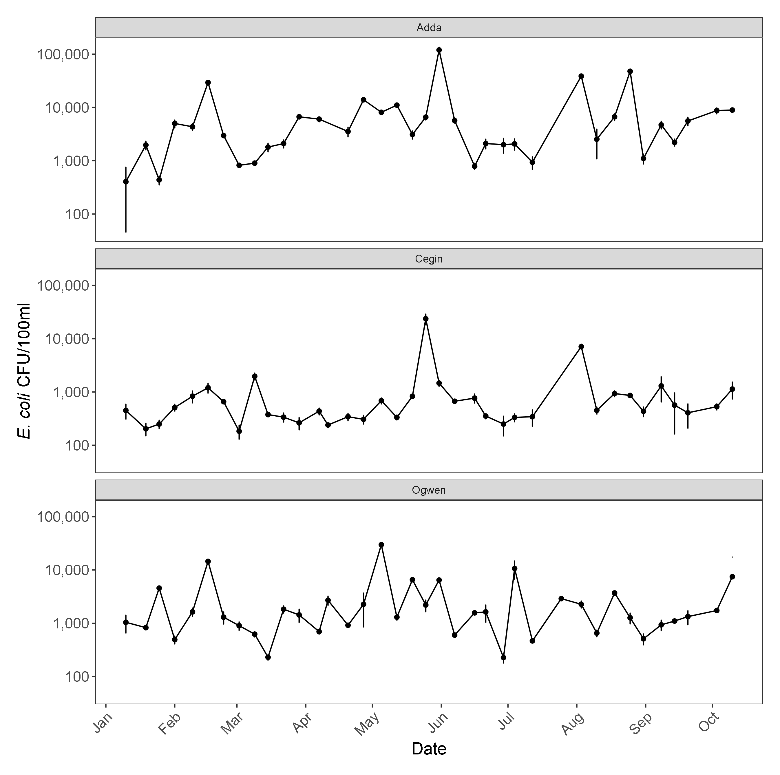Figure 3.8. Mean E. coli values ± standard deviation for replicate water samples taken from the Afon Adda, Afon Cegin and Afon Ogwen from January - October 2022. Note the log scale of the y axis.
A significant difference between the log10 transformed mean E. coli concentrations observed in the three rivers was detected (Repeated Measures ANOVA: F_{2, 70} = 38.61, p < 0.001). Post-hoc pairwise t test with a Bonferroni adjustment comparison showed that each river was significantly different to the other two rivers. Within the context of the E. coli concentrations observed, the concentrations of samples taken from the Afon Adda were significantly higher than those taken from the Afon Ogwen, which were higher than those taken from the Afon Cegin (Figure 3.9). It should be noted that whilst the E. coli concentrations were highest in the Afon Adda, it is likely to have the lowest flow rate of the three rivers and its relative microbial flux to coastal water is unknown. Therefore, it would be advantageous to have information on the discharge magnitudes of the Afon Adda and Afon Cegin in addition to the Afon Ogwen. Differences in E. coli concentrations in the rivers mirrored those observed in the concentrations of crAssphage.
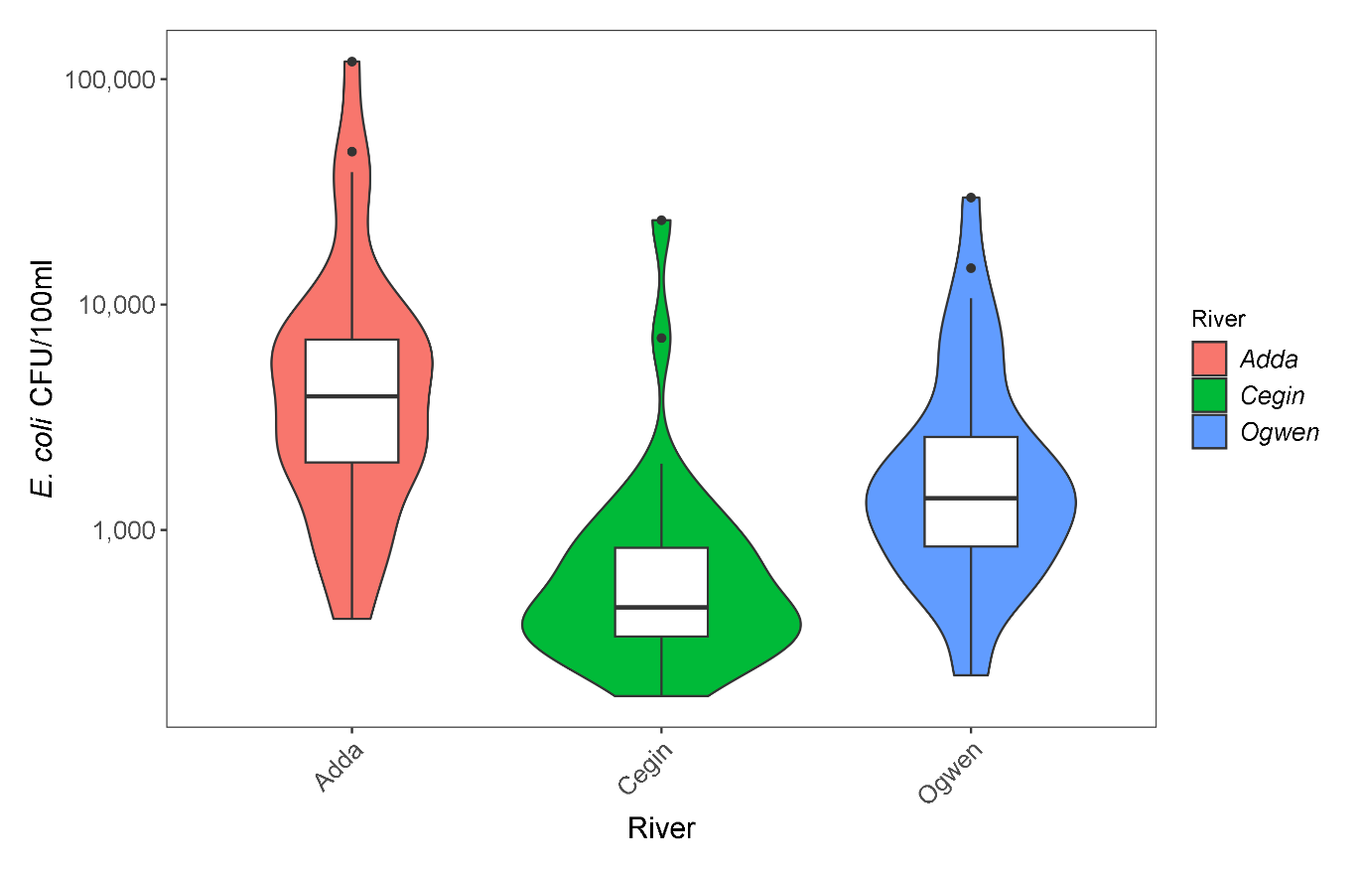Figure 3.9. Violin plot with overlying box plot showing the distribution of replicate-mean E. coli concentrations observed in Afon Adda, Afon Cegin and Afon Ogwen from January – October 2022. The black line within the box indicates the mean value observed, the top and bottom limits of the box indicate the 75th and 25th percentiles respectively and the upper and lower limits of the whiskers indicate the 90th and 10th percentiles respectively. Note the log scale of the y-axis.
E. coli concentrations in seawater samples at the monitoring points were generally orders of magnitude lower than those observed in the rivers, indicating significant dilution of E. coli upon discharge into the Menai Strait. The highest mean E. coli concentration was observed in the Ogwen Channel sampling point (106 E. coli/100ml; Figure 3.10).
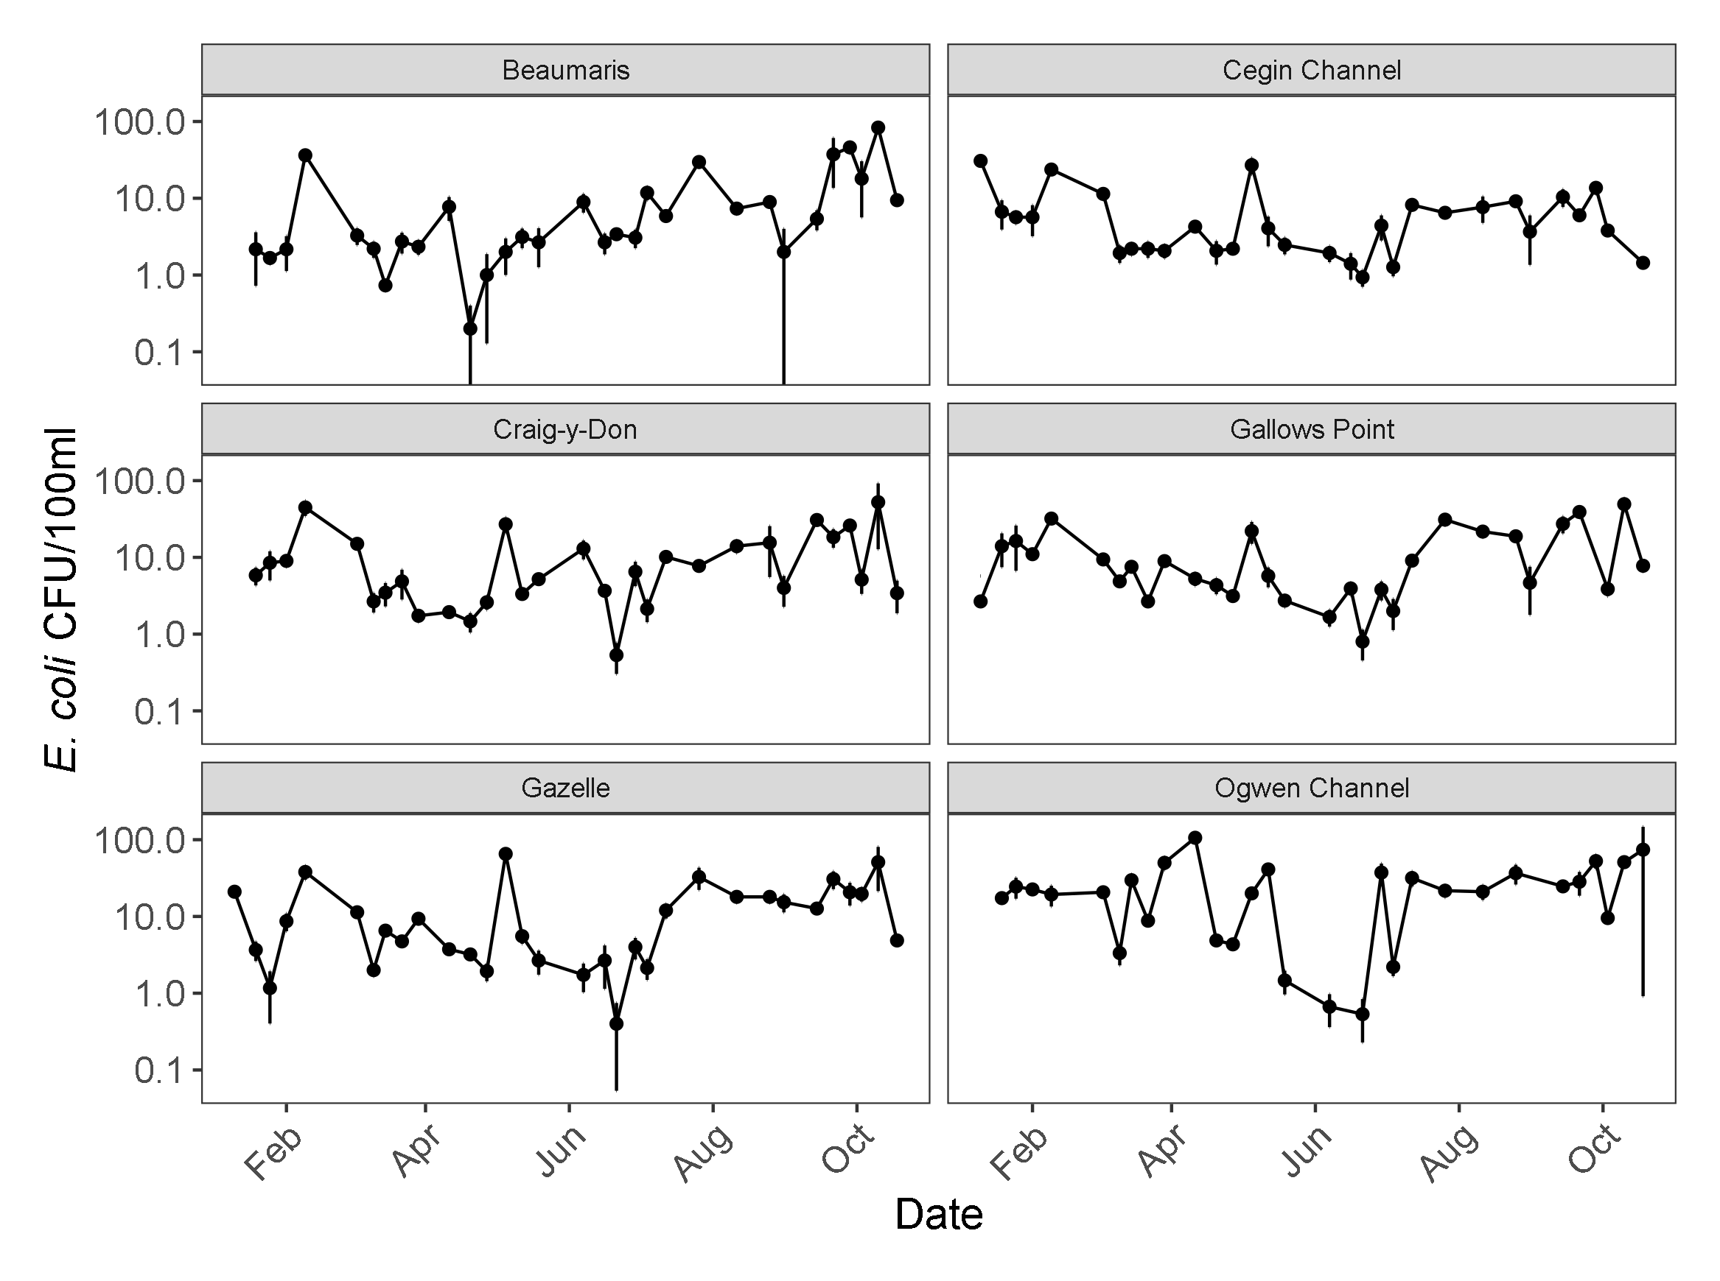Figure 3.10. Mean E. coli values ± standard deviation for triplicate surface water samples taken from the shellfish water monitoring points from January - October 2022. Note the log scale of the y axis.

3.2.2. Shellfish
The E. coli concentrations in mussels at the RMPs reported results consistent with the class B classification for Gallows Point, Ogwen Channel and West of Bangor Pier, and with the seasonal A classification for the Cegin Channel (Figure 3.11). The highest result observed was 4600 MPN/100g at the West of Bangor Pier RMP on 05/05/2022. This coincided with results >700 MPN/100g at the Cegin Channel and Gallows Point RMPs, as well as the highest E. coli concentration observed as part of the routine sampling of the Afon Ogwen. High concentrations of crAssphage were also observed on 05/05/2022 in the Gallow’s Point, West of Bangor Pier and Cegin Channel RMPs with values of 1962, 11,795, and 1704 gc/g respectively. This suggests that to some extent human sources contributed to faecal pollution in the shellfish at these sites on this date. A repeated measures ANOVA was used to assess whether the E. coli concentrations observed in the routine monitoring differed between the RMPs. No significant difference between RMPs was observed (Repeated measures ANOVA; F_{3, 78} = 0.187, p = > 0.05). Concentrations of E. coli in the mussels sampled at the RMPs were higher than those observed in the water samples taken from the RMP or nearby the RMP, emphasising the potential for mussels to accumulate faecal indicator bacteria.
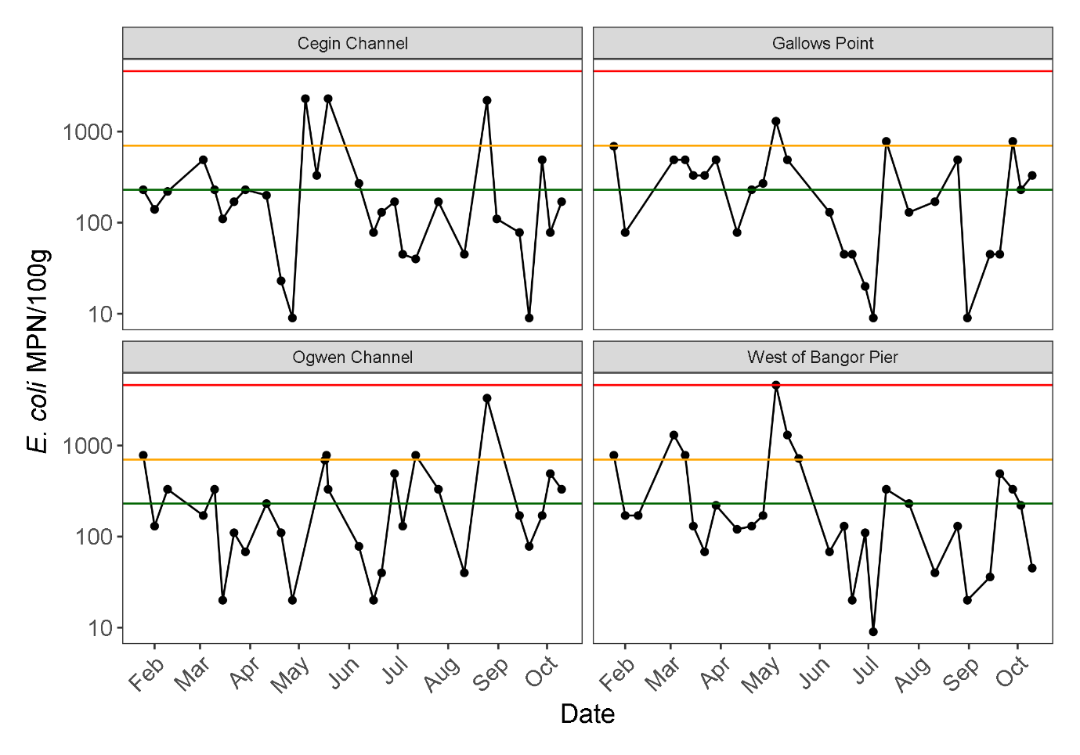Figure 3.11. E. coli concentrations measured via the MPN method in mussel samples taken from the shellfish representative monitoring points from January – October 2022. Note the log scale of the y axis. The coloured horizontal lines represent the different thresholds whereby exceedances may lead to classification changes. The green, yellow and red lines represent 230, 700 and 4600 E. coli/100g shellfish flesh respectively.

No significant relationship was observed between E. coli concentrations in shellfish at the West of Bangor Pier and the Cegin Channel RMPs (Figure 3.12). Significant moderate correlations were observed between the remaining RMPs. The RMPs at Gallows Point and West of Bangor pier shellfish production area reported the strongest correlation between two RMPs, whilst a moderate correlation was observed between the E. coli concentrations at the Cegin Channel and Ogwen Channel RMPs. These correlations indicate that the E. coli concentrations in the RMPs are driven, to some extent, by common factors.
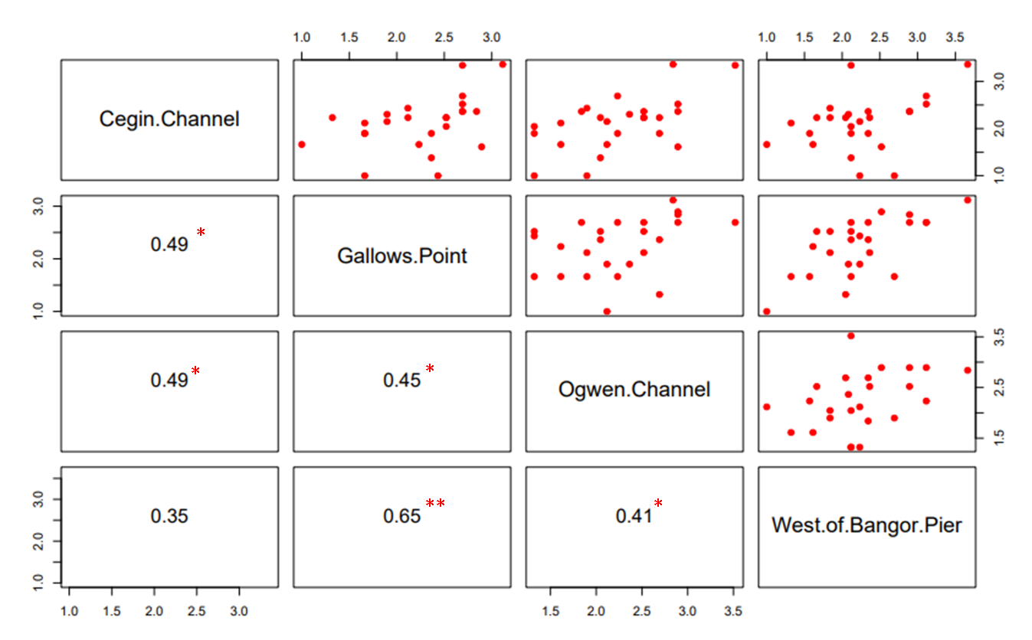Figure 3.12. Log 10 Paired plots and Spearman’s rank correlation coefficient values between E. coli concentrations reported by the MPN method at the RMPs of the 4 mussel production areas. The red asterisks indicate a significant correlation coefficient (p < 0.001 [***]; p < 0.01 [**]; p < 0.05 [*]).
A stepwise regression was used to identify explanatory environmental variables at each RMP, with daily rainfall from the Bethesda Quarry rain gauge (Appendix 5), river level at the Afon Ogwen sampling point, and lagged rainfall and lagged river level included. Lagged rainfall and lagged river level reference the previous days data, as peaks in discharge during events tended to occur within 24 hours of elevated rainfall occurring, indicating the time it takes for rainfall in the catchment to be expressed in the rivers. River level was used to indicate discharge magnitude at the Afon Ogwen because the discharge data was poor quality when the river level was too low, as defined previously. In the Cegin Channel and Ogwen Channel RMPs, E. coli concentrations were identified as being associated with the rainfall the previous day. The Gallows Point and West of Bangor Pier RMPs did not show any association with rainfall or river level regardless of incorporating lag (Table 3.4).

Table 3.4. Environmental predictor variables identified as significant by a stepwise regression ran for individual RMPs. A tick indicates a significant result at the 5%, a cross indicates that the variable was not significant.
Site | Rainfall | Rainfall +1 Day | Ogwen Level | Ogwen Level +1D | R²
Cegin Channel | û | ü | û | û | 0.17
Gallows Point | û | û | û | û | -
Ogwen Channel | û | ü | û | û | 0.16
West of Bangor Pier | û | û | û | û | -

Multiple linear regressions were used to assess whether the E. coli concentrations in mussel samples taken at the RMP were related to E. coli concentrations in river water in the Afon Adda, Afon Cegin and Afon Ogwen. The previous day’s rainfall was included as a predictor variable for the Cegin Channel and Ogwen Channel RMPs. Interactions between the effects of the lagged rainfall and the E. coli concentrations in the rivers on the E. coli concentrations at the RMP were also explored for the Cegin Channel and Ogwen Channel RMPs. The highest reported adjusted R² value was for the Ogwen Channel RMP, where the predictors included accounted for 86% of the variability in the E. coli concentrations observed. Whilst E. coli concentrations at the Afon Ogwen significantly influenced the concentrations of E. coli at the Gallows Point RMP, the model accounted for 29% of the variability (Table 3.5). The E. coli concentrations observed at the Afon Ogwen were identified as being a significant predictor of E. coli concentrations from shellfish sampled at all RMPs (Table 3.6). Lagged rainfall was identified as a significant mediator of the effect of the E. coli concentration of the Afon Ogwen on the E. coli concentration at the Ogwen Channel RMP. This suggests that the previous days rainfall could influence the RMP via its interaction with the E. coli concentrations at the RMP. The Ogwen channel RMP is in closest proximity to the Afon Ogwen. It is possible that including rainfall data from other sources might improve models for which the variability is less well explained by the predictors included.

Table 3.5. Results of the multiple linear regressions investigating the relationships between E. coli concentrations in river water and the E. coli concentrations observed in the shellfish sampled at the RMPs.
Shellfish RMP | F | df | R² | p
Cegin Channel | 6.91 | 7, 19 | 0.61 | < 0.001
Gallows Point | 4.29 | 3, 21 | 0.29 | 0.016
Ogwen Channel | 24.58 | 7, 18 | 0.86 | < 0.001
West of Bangor Pier | 15.59 | 3, 23 | 0.63 | < 0.001

Table 3.6. Summary of the predictors identified by regressions presented in table 3.5 as having a significant effect on the E. coli concentrations observed in the shellfish sampled at the RMPs
Shellfish RMP | Predictors | p value
Cegin Channel | Afon Ogwen | 0.01
Gallows Point | Afon Ogwen | <0.01
Ogwen Channel | Afon Ogwen  Afon Ogwen * Lag Rainfall | < 0.01  < 0.01
West of Bangor Pier | Afon Ogwen | < 0.01

3.3 Event sampling

3.3.1 Event I
During this event duration there was significant rainfall from 15:00 17/05/22 with a peak intensity of 4.2mm / hr at 19:00. (Figure 3.13). The water level of the Afon Ogwen responded, rising from 18:00 on 17/05/22 until 01:00 on 18/05/22. Thereafter the level decreased slowly. E. coli concentrations in samples collected by the autosampler were relatively low until 19:00 17/05/22, when a maximum concentration of 4900 CFU/100ml was observed. This was about 2 hours after the beginning of significant rainfall intensity and before the river reached peak level. E. coli concentrations decreased sharply from 00:00 18/05/22. However, the river level was still high, suggesting a larger discharge, so the E. coli flux was probably still high relative to pre-event. Pooled autosampler samples covering the period from 13:00 on 17/05/22 to 02:00 on 18/05/22 showed a crAssphage concentration of 1428 gc/100ml (crAssphage being associated with human discharge), however no NoV was detected.
Mussels were collected from the Ogwen RMP at 17:15 on 17/05/22 (~LW) 17:45 on 18/05/22 (~LW) and 14:20 on 19/05/22 (~HW, routine sampling). The derived E. coli concentration varied according to the method used. The Impedance method gave very high results relative to MPN and pour plate methods (Figure 3.14). CrAssphage and NoV GII concentrations in mussels at the RMP did appear to respond to the rainfall event, rising to 1127 gc/g and 281 gc/g, respectively on 18/05/22 after not being detected the previous day. There was no relationship between shellfish E. coli and virus concentrations in samples collected during this event.

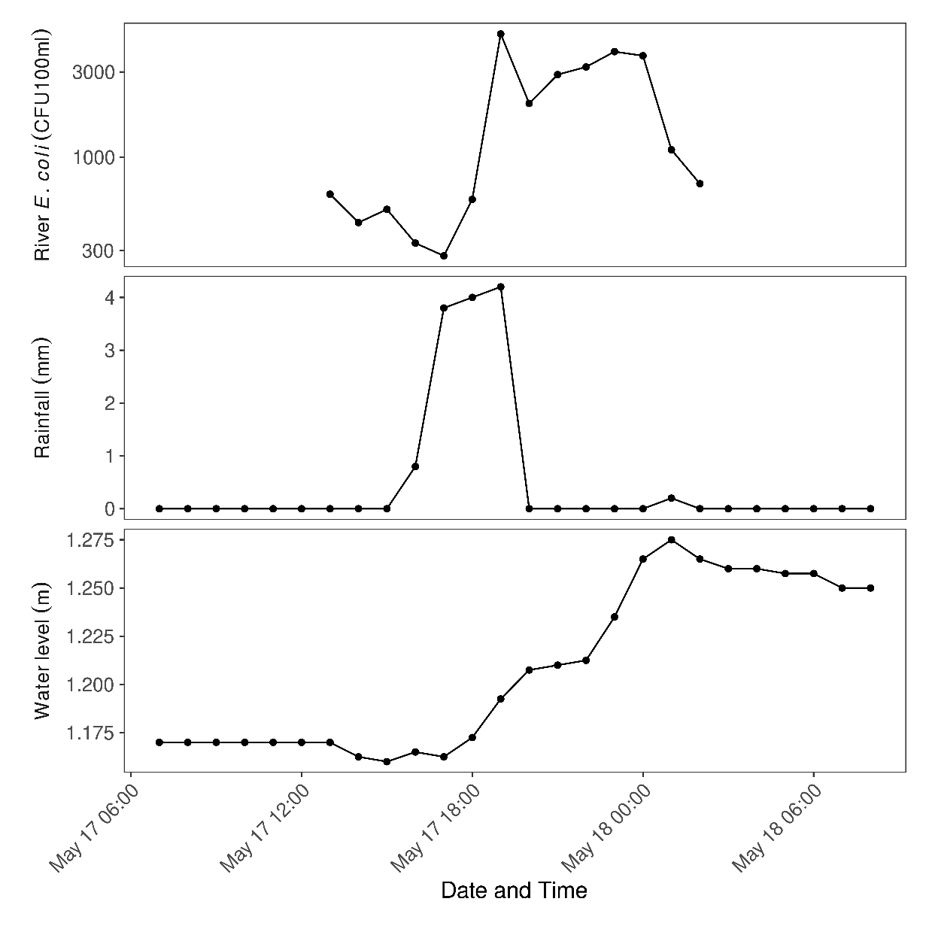
Figure 3.13. Concentration of E. coli in river water samples taken from Afon Ogwen, river level, and rainfall during Event I.

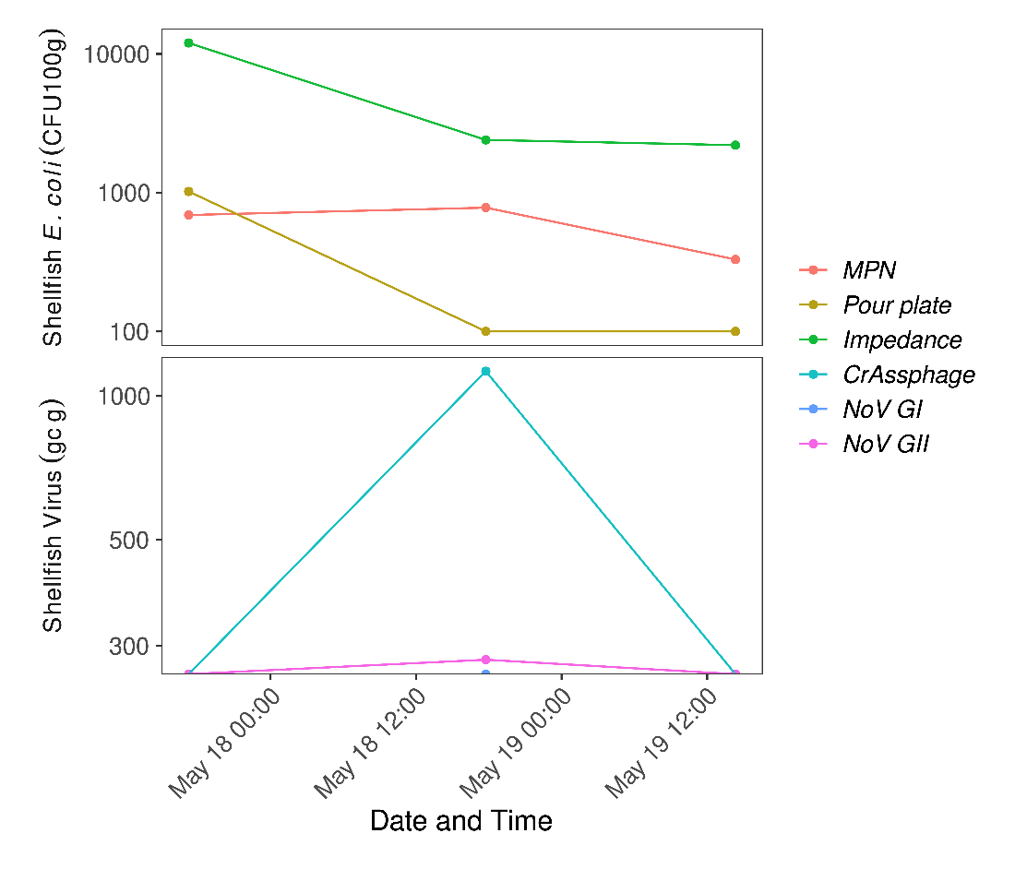
Figure 3.14. Concentration of E. coli (MPN, pour plate and impedance methods) and viruses in shellfish taken from the Ogwen RMP site during Event I.

3.3.2 Event II
Rain fell less intensely over a longer period than for event I, with a total of 10.8 mm falling between 10:00 on 28/06/22 and 13:00 on 29/06/22 (Figure 3.15). At the start of the event, the Afon Ogwen river level was declining after no rain since 0700 on 27/06/22. The water level of the Afon Ogwen gradually increased during the event from around 17:00 on 28/06/22 until 00:00 on 29/05/22 where the water level remained high. During the event, mean E. coli levels fluctuated between 600 and 1400 CFU/100ml. E. coli quantities did not appear to spike in a clear response to rainfall as in event I (3.2.1.1).
Routine mussel samples were collected at high tide between 11:00-13:00 on 29/06/22. E. coli concentrations were 490MPN/100g and 100 CFU/100g (Ogwen Channel), 170 MPN/100g and 100 CFU/100g (Cegin Channel), 110 MPN/100g and 100 CFU/100g (West of Bangor Pier), 20 MPN/100g and 100 CFU/100g (Gallows Point).

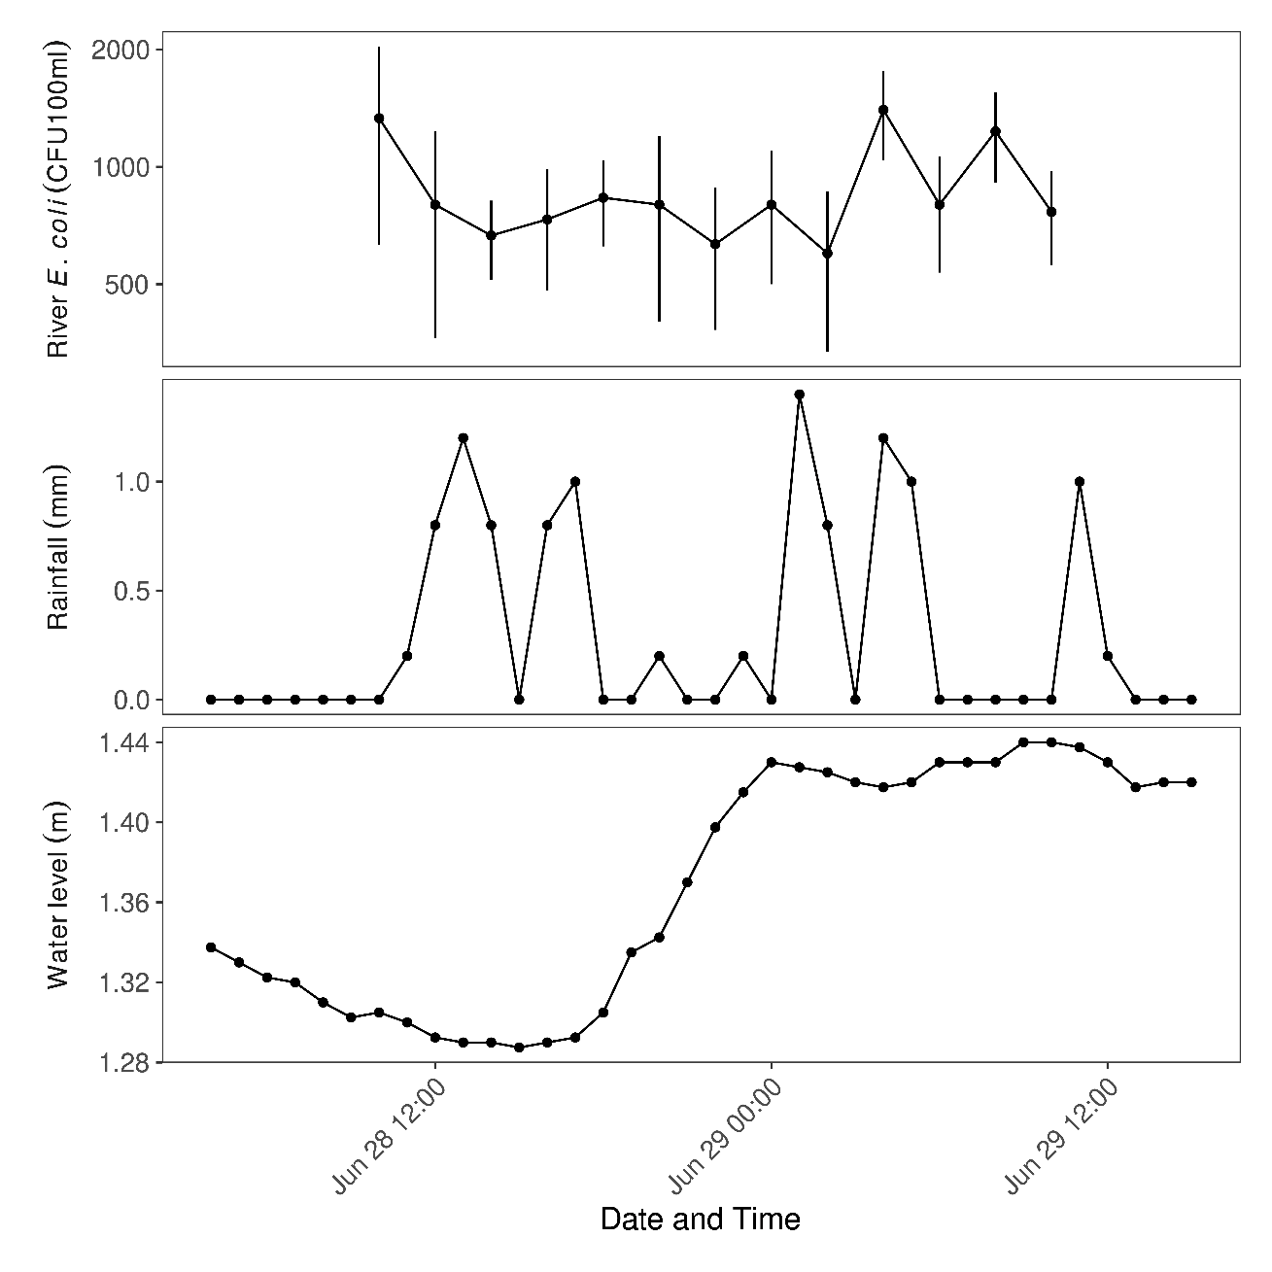
Figure 3.15. Concentration of E. coli (mean ± SD) in triplicate surface water samples taken from the Ogwen river and corresponding rainfall and river water levels during the rain event (II) sampling period.

3.3.3 Event III
Light rainfall fell sporadically from 21:00 on 25/09/22. Then there was 26.8 mm rain on 30/09/22 (Figure 3.16). Over the event, a total of 50.6 mm rain fell. Discharge data for the Afon Ogwen were good quality after 26/09/22, allowing calculation of E. coli flux at sampling time-points. Discharge peaked at 12.29 m³/s and 23.31 m³/s on 29/09/22 and 30/09/22, respectively. Local wastewater sampling (Treborth WwTW) showed the presence of NoV GI and GII in the community, with higher concentrations of GII. Peaks were 179,054 gc/l and 1,776,185 gc/l respectively.
E. coli concentration in the Afon Ogwen was highest in the first sample taken (6533 CFU/100ml), but higher predicted E. coli flux occurred later when discharge (m³/s) increased (Table 3.7). The highest time-point value suggested 303,300,000 CFU/s discharged at 09:15 on 29/09/22. The E. coli flux could have been higher at peak discharge (23.31 m³/s on 30/09/22) but we do not have a corresponding concentration sample.

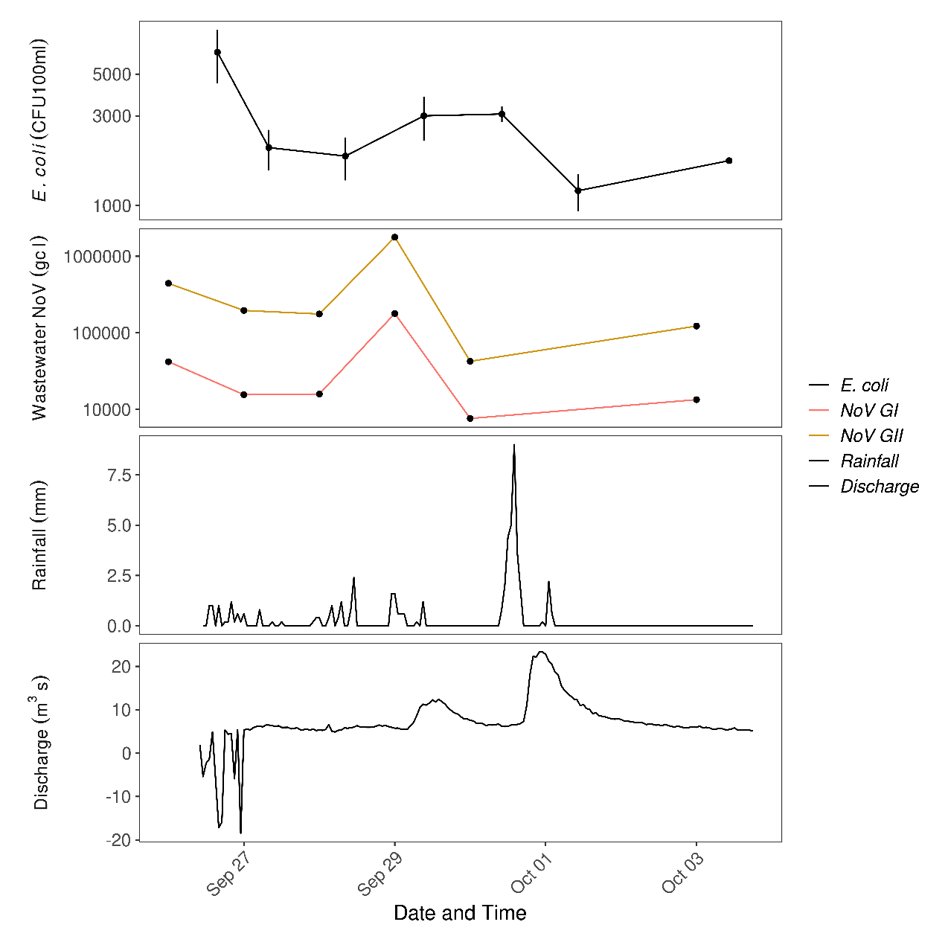
Figure 3.16. Concentration of E. coli (mean ± SD) in triplicate surface water samples taken from the Afon Ogwen. Also showing local (Treborth) wastewater NoV levels, rainfall and Afon Ogwen discharge during event III.

Table 3.7. Calculations of predicted E. coli flux from the Ogwen river during event III
Date | Time | E. coli (CFU/100ml) | Discharge (m³/s) | Total E. coli discharged  (CFU/s)
27/09/2022 | 07:55 | 2033 | 6.29 | 127,875,700
28/09/2022 | 08:17 | 1833 | 5.35 | 98,065,500
29/09/2022 | 09:15 | 3000 | 10.11 | 303,300,000
30/09/2022 | 10:05 | 3067 | 6.52 | 199,968,400
01/10/2022 | 10:19 | 1200 | 11.51 | 138,120,000
03/10/2022 | 10:21 | 1733 | 5.72 | 99,127,600

We monitored E. coli and virus concentrations in the Afon Ogwen and also the Afon Adda and Afon Cegin. Time-point E. coli concentrations in the Afon Adda (3200 to 60,333 CFU/100 ml) were higher than in the Afon Cegin and Afon Ogwen by (Figure 3.17). The trends in E. coli concentration in each river differed. The Afon Adda and Afon Cegin showed highest E. coli concentrations on 01/10/22, following the heaviest rainfall on 30/09/22, whilst the Afon Ogwen showed its lowest E. coli concentrations on 01/10/22.
CrAssphage and NoV (GI, GII) were detected in all rivers (Figure 3.17). No viral data is available for 30/09/22 or 01/10/22. NoV (GI, GII) concentrations were no longer detectable in the Afon Adda and Afon Ogwen by 03/10/22. They declined more rapidly in the Afon Ogwen. NoV GII was detected in the Afon Cegin on the first and final day of the event. NoV GI was detected only on the first day and at a low quantity. CrAssphage was present in every sample, at higher concentrations than NoV GI and GII.
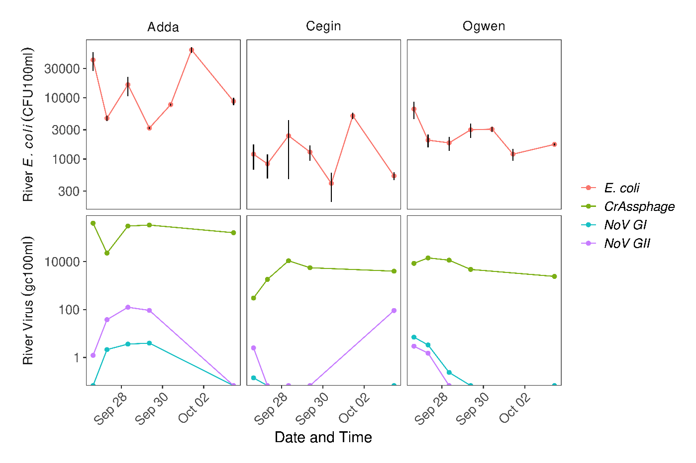
Figure 3.17. Concentration of E. coli (mean ± SD) in triplicate river water samples taken from the Afon Adda, Afon Cegin and Afon Ogwen and corresponding virus levels during event III
We also monitored shellfish at RMPs. We were able to access the Cegin Channel and West of Bangor Pier RMPs frequently at LW. There were large fluctuations in shellfish E. coli concentrations (Figure 3.18). E. coli concentrations derived by MPN in mussel samples ranged between 78-4900 MPN/100g at Cegin Channel RMP and 170-3300 MPN/100g at West of Bangor Pier RMP, with the highest peaks on 01/10/22 at both sites. Pour plate results showed lower ranges overall (100-920 CFU/100g and 100-1460 CFU/100g respectively). The methods showed similar trends, including a response to the high rainfall of 30/09/22. CrAssphage, NoV (GI, GII) were detected at both sites. There was no clear relationship between E. coli and virus concentrations in shellfish during the event. When detected, crAssphage was quantified at higher concentrations than NoVs. But NoVs were present in the absence of crAssphage at Cegin Channel after 28/09/22. NoVs were not detected at either site from 02/10/22.
Mussels at Gallows Point and Ogwen Channel RMPs were also sampled at HW on 28/09/22 and 03/10/22 and analysed for E. coli and viruses. On 28/09/22 and 03/10/22 Gallows Point RMP returned E. coli concentrations of 780 MPN/100g or 100 CFU/100g and 230 MPN/100g or 100 CFU/100g, respectively. On 28/09/22 and 03/10/22 Ogwen Channel RMP returned E. coli concentrations of 170 MPN / 100g or 640 CFU / 100g and 490 MPN / 100g or 100 CFU / 100g, respectively, such that the methods reported different directions of change (data not displayed).

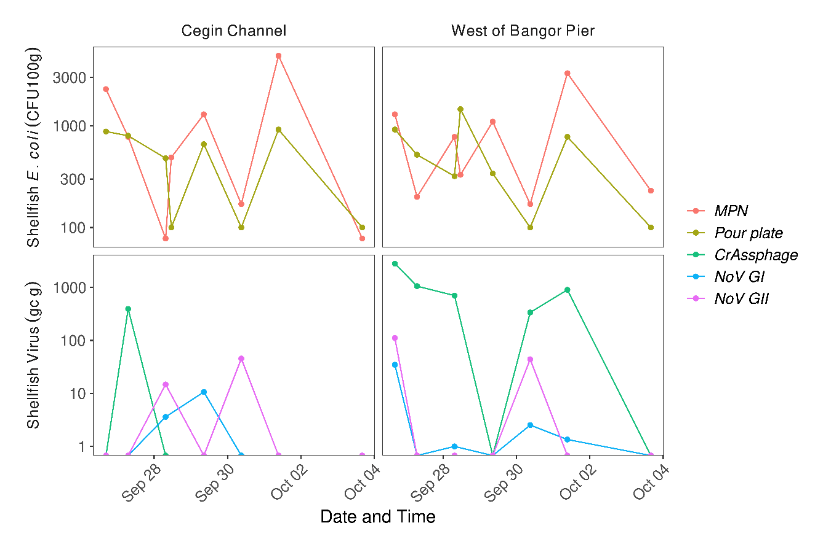
Figure 3.18. E. coli concentration in mussels determined using MPN and pour plate methods and corresponding digestive tissue virus concentrations for Cegin Channel and West of Bangor Pier RMPs. during event III.

Triplicate passive samplers were deployed at the Afon Ogwen river sampling location on 26/09/22 at 15:35, 27/09/22 at 07:55 and 30/09/22 at 10:05. Assuming viral saturation of samplers after 6-8h, data indicate total viral accumulation from the Afon Ogwen river in the 6-8h period after deployment. NoV GII was not detected in any sample (Figure 3.19). CrAssphage was detected at higher concentrations than NoV GI. Over the days sampled, NoV GI decreased in concentration.

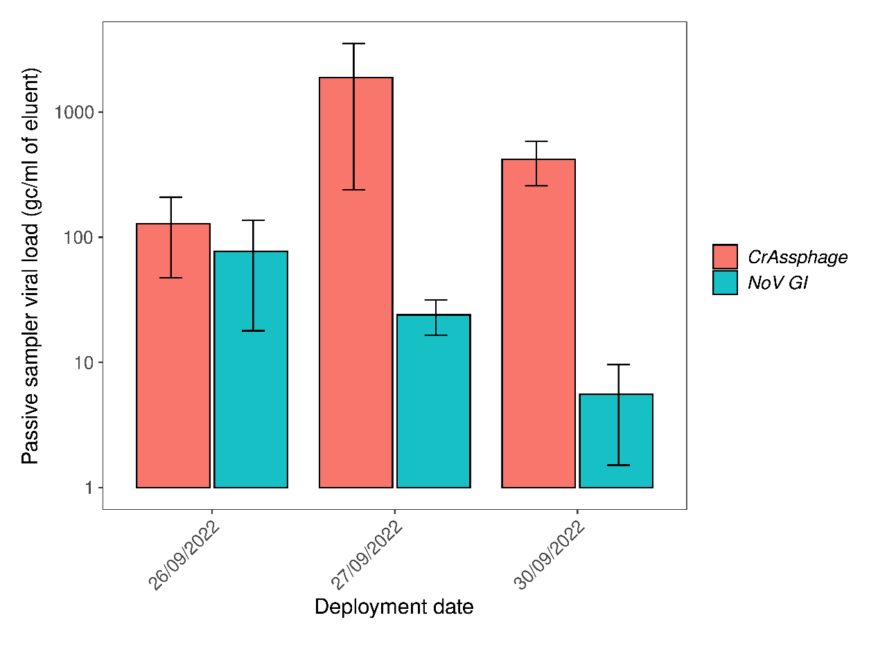

Figure 3.19. Quantities (mean ± SE) of crAssphage and NoV GI detected in passive samplers deployed at the Afon Ogwen during the rain event III.

3.4 E. coli quantification in shellfish, methodology comparison

As described in the Methods, the pour plate and MPN methods of E. coli enumeration were applied to mussel samples in parallel (Figure 3.20). Classification of shellfish beds is determined based on E. coli concentrations in monitoring results over a 3-year period, but this study did not include one full years’ data, so it was not appropriate to speculate on whether the methods used would have resulted in different classifications of a production area. However, it is possible to assess the relative frequencies of results which exceed the threshold boundaries.
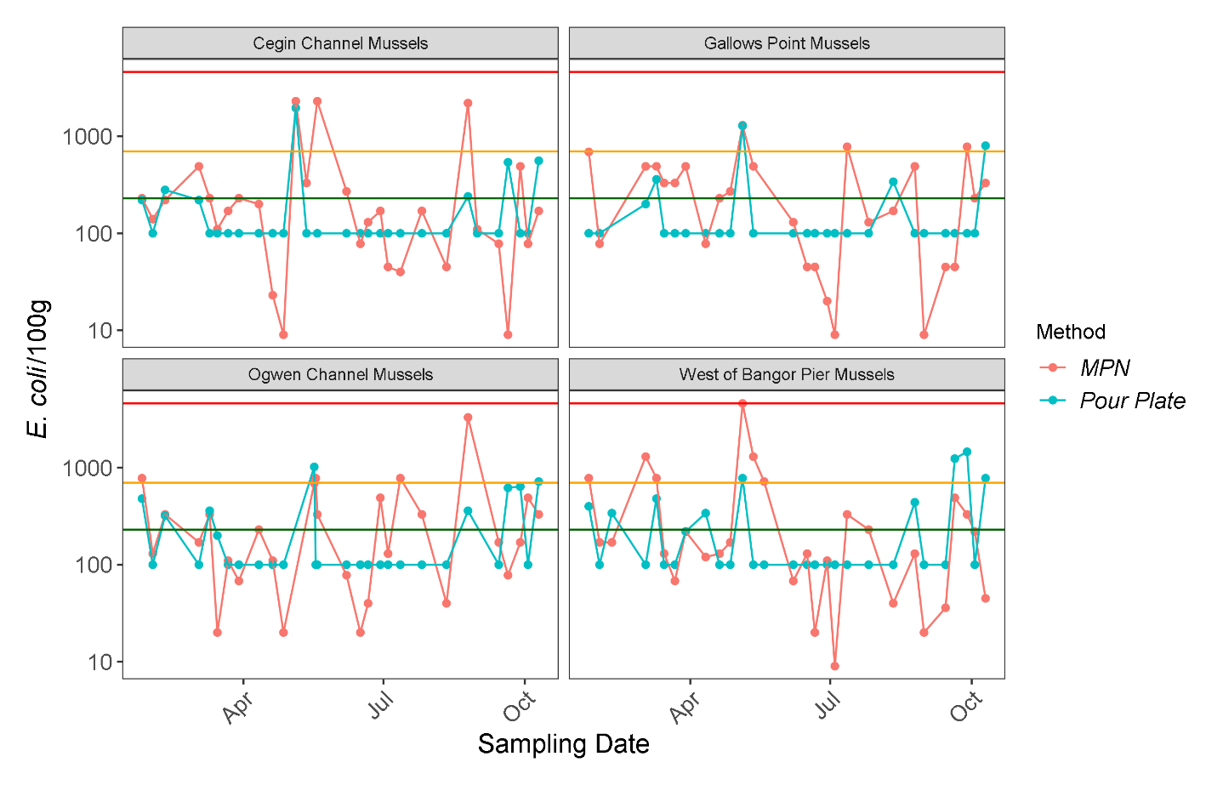Figure 3.20. E. coli concentrations determined by MPN and pour plate methods for mussel samples taken in routine sampling of shellfish Representative Monitoring Points from January – October 2022. Note the log scale of the y axis. The coloured horizontal lines represent the different thresholds whereby exceedances may lead to classification changes. The green, yellow and red lines represent 230, 700 and 4600 E. coli/100g shellfish flesh respectively. All data below the limit of quantification has been attributed a value of half of the limit.

When measured by the MPN method, the frequency of values exceeding 230 E. coli/100g was greater than the maximum frequency of exceedances (20%) allowable for class A, over the entire sampling period for all RMPs studied (Table 3.8). The pour plate method resulted in less frequent exceedances of 230 E. coli/100g than the MPN method, and in the cases of Cegin Channel RMP and Gallows Point RMP, this was less than 20%. However, over a 10-month period, all sites reported at least one result > 700 E. coli/100g when measured by either the pour plate or MPN methods (Figure 3.20). Thus, both methods returned results consistent with the definition of a class B area, for all sites. However, the pour plate results indicate potential for seasonal A classifications at other RMPs, in addition to Cegin Channel. It should be noted that the high frequency of sampling undertaken by our study is associated with a greater likelihood of capturing high contamination events than for official control sampling.

Table 3.8. Relative frequencies of E. coli concentrations reported by the MPN and pour plate methods that were above or below exceedance thresholds. For a class A area 80% of samples must be ≤ 230 E. coli/100g. Numbers in brackets refer to number of samples that exceeded 700 E. coli/100g.
Method | RMP | ≤ 230 | > 230 - ≤ 4600 | > 700 | > 4600
MPN | Cegin Channel | 75.86 | 24.14 | 10.34 (3) | 0
 | Gallows Point | 51.85 | 48.15 | 11.11 (3) | 0
 | Ogwen Channel | 57.14 | 42.86 | 14.29 (4) | 0
 | West of Bangor Pier | 68.96 | 31.04 | 20.69 (6) | 0
Pour Plate | Cegin Channel | 82.76 | 17.24 | 3.45 (1) | 0
 | Gallows Point | 85.19 | 14.81 | 7.41 (2) | 0
 | Ogwen Channel | 71.43 | 28.57 | 7.14 (2) | 0
 | West of Bangor Pier | 68.97 | 31.03 | 13.79 (4) | 0

A paired t-test was used to assess whether the MPN and pour plate methods reported significantly different E. coli concentrations across the 4 RMPs monitored in the Menai East area. When data below the limit of quantification of the MPN and pour plate methods were treated as half of the limit of quantification, as would be applied in official control results (9 MPN/100g, 100 CFU/100g), no significant differences were observed across all sites or within individual sites (Table 3.9). A further array of paired t-tests was performed with the inclusion of all data points below the limit of quantification. In this case, significant differences were observed between the pour plate and MPN methods across all sites and in the Gallows Point and Ogwen Channel RMPs individually (Table 3.10), with the MPN method reporting higher E. coli concentrations than the pour plate method (Figure 3.21). The different outcomes of these two approaches is likely due to the high frequency of very low pour plate results, and the strong influence on the statistical analysis of rounding these up to 100 CFU/100g.

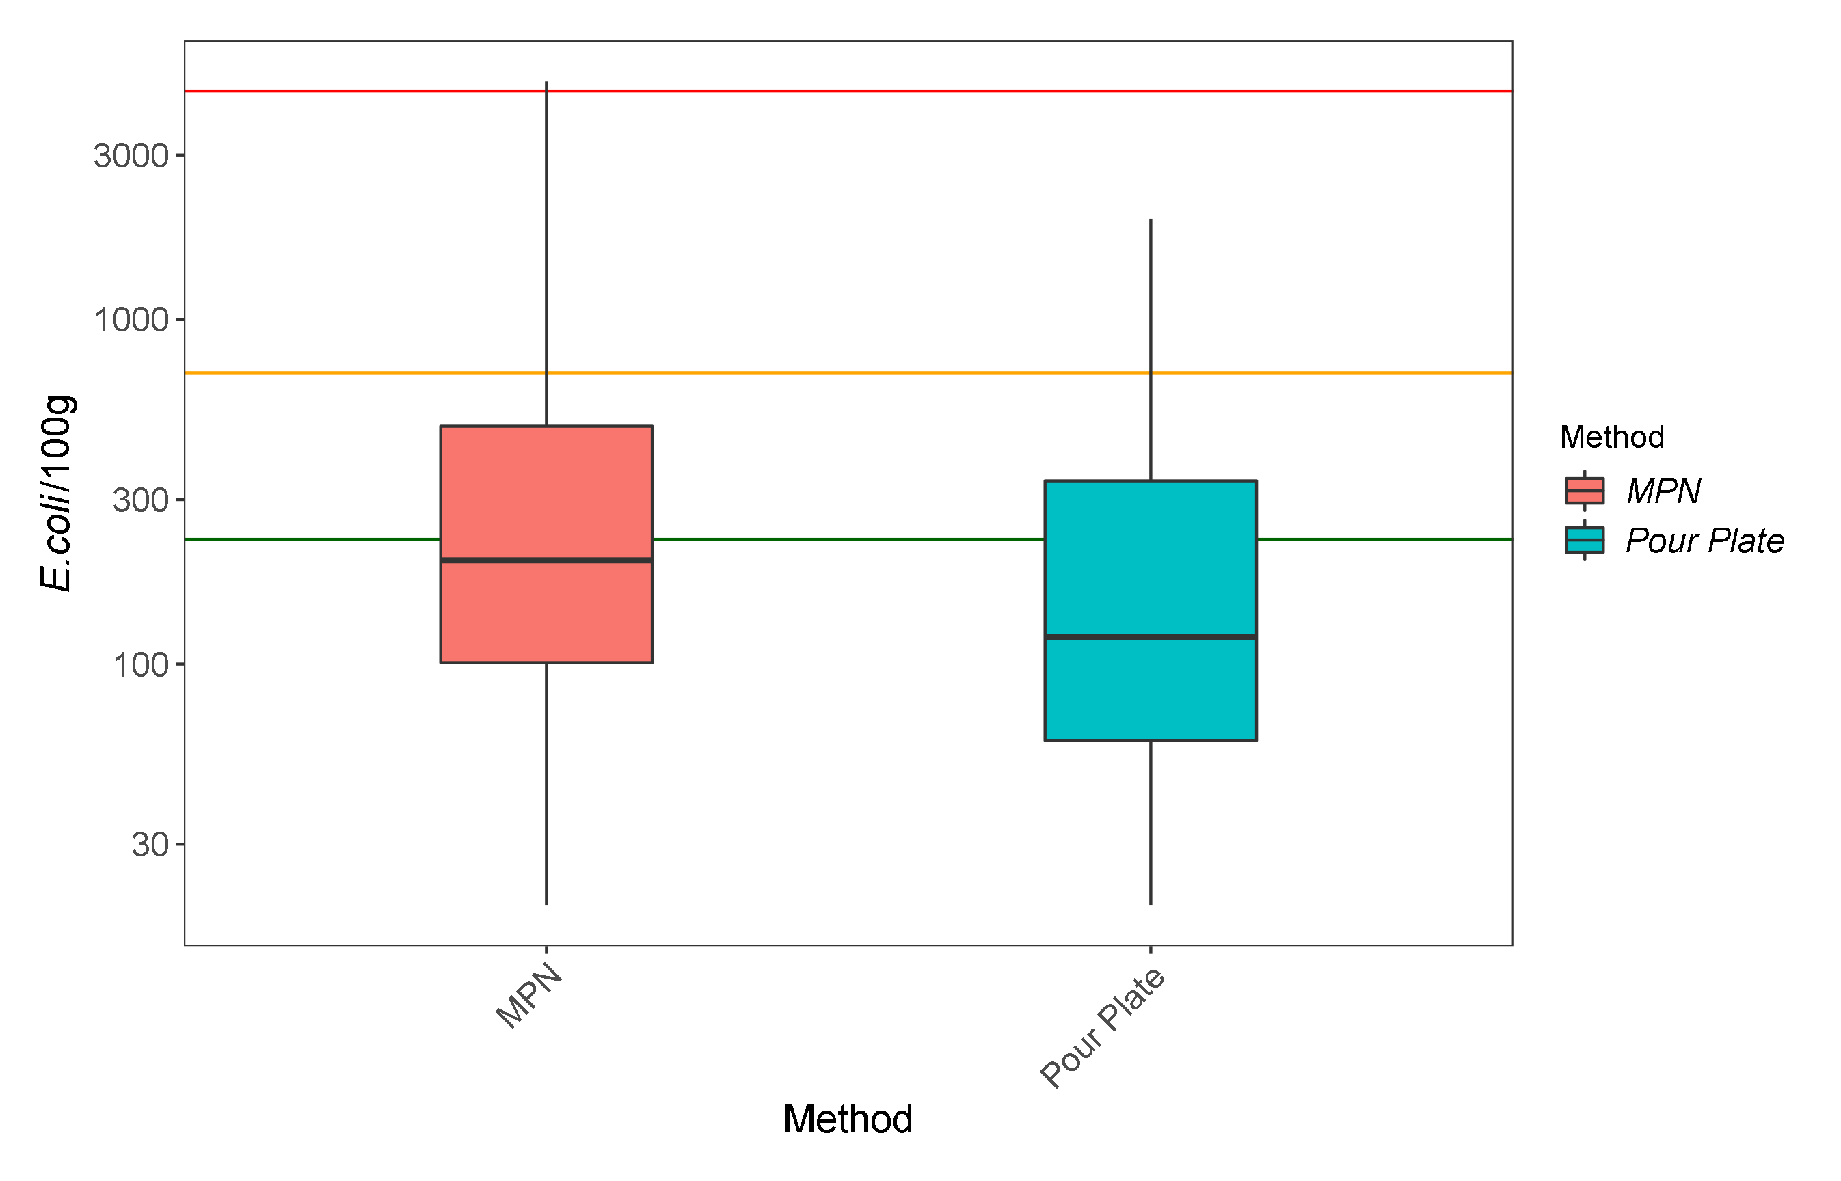Figure 3.21. Boxplot of the comparison between MPN and Pour Plate E. coli/100g in mussels located within the Menai Strait. The heavy bar shows the median and each box covers the interquartile range. Data below the limit of quantification have not received any treatment.

Table 3.9. Results of paired t-tests assessing differences in E coli concentrations reported by the MPN and pour plate methods within sites and across all sites. MPN and pour plate values below the limit of quantification have been assigned a value of half of the limit of quantification (MPN < 18 = 9 MPN/100g, pour plate < 200 = 100 CFU/100g).
Site | T value | Mean difference | df | p
All | 1.58 | 0.05 | 124 | 0.12
Cegin Channel | 0.87 | 0.05 | 34 | 0.39
Gallows Point | 1.04 | 0.10 | 26 | 0.31
Ogwen Channel | 0.59 | 0.04 | 27 | 0.56
West of Bangor Pier | 0.41 | 0.02 | 34 | 0.69

Table 3.10. Results of paired t-tests assessing differences in E. coli concentrations reported by the log10 transformed MPN and the pour plate methods within sites and across all sites. Data below the limits of quantification have not been treated. Data includes all paired MPN and pour plate values, including samples taken during targeted events.
Site | T value | Mean difference | df | p
All | 3.81 | 0.26 | 124 | < 0.001
Cegin Channel | 1.58 | 0.22 | 34 | 0.12
Gallows Point | 2.24 | 0.36 | 26 | 0.03
Ogwen Channel | 2.40 | 0.32 | 27 | 0.02
West of Bangor Pier | 1.47 | 0.17 | 34 | 0.15

Visually assessing the paired data using a Bland-Altman approach indicated that there was a mean bias towards the MPN compared to the pour plate (Figure 3.22). The bias towards the MPN when compared to the pour plate was –0.26 log 10 E. coli/100g. The MPN method tended to report higher E. coli concentrations than the pour plate method (Figure 3.21). A total of 8 out of 125 samples (6.4%) fell outside of the 95% confidences intervals, indicating that the two methods did not demonstrate sufficient agreement. However, this lack of agreement came from 4 samples above the confidence intervals and 4 samples below. Thus, the results were not indicative of either method reporting much higher E. coli concentrations than the other.

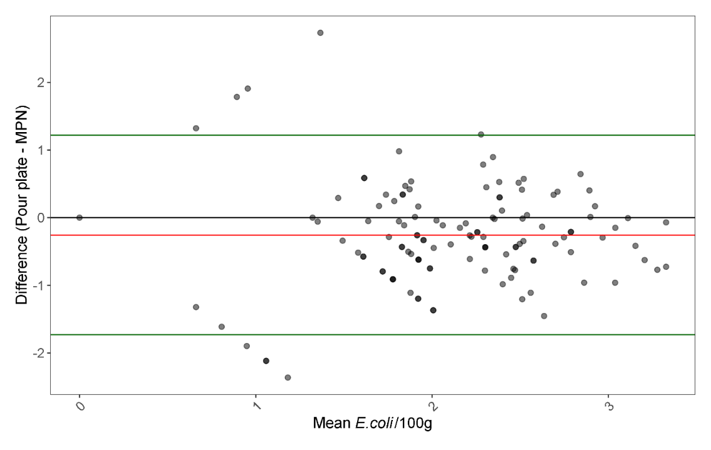
Figure 3.22. Bland-Altman plot of the differences between paired log 10 E. coli/100g results reported by the MPN and pour plate methods plotted against the mean log 10 E. coli/100g result for the two methods. Differences are presented as log 10 pour plate result subtracted by the log 10 MPN result. The red line indicates the mean difference, and the green lines indicate the 95% confidence intervals which are generated as the mean ± 1.96 x standard deviation. Points are plotted with transparency, so the darkness of the points indicates multiple measurements with the same differences/means.

4. Discussion

4.1 Sources of contamination

Results from this study confirm that there is human wastewater-derived contamination in the shellfishery at the eastern end of the Menai Strait and in its major freshwater inputs. Human mastadenovirus F, human gut-associated crAssphage and, occasionally human NoVs, were detected and quantified in all sample types (river water, sea water and shellfish) during the weekly monitoring and event sampling campaigns. Human mastadenovirus F, and especially crAssphage, were frequently detected in river waters. We also detected correlation between crAssphage and E. coli concentrations. Cattle and sheep-associated atadenovirus was only present in one sample throughout the study (Afon Ogwen river water), suggesting that microbial pollution due to agricultural activities may be of less importance in contamination of the shellfish fishery and surrounding water bodies. It is noted that more studies comparing animal vs. human input would be necessary for more accurate evaluation and source tracking. Significant associations between E. coli, crAssphage and the nutrients examined further support the view that wastewater is an important source of microbial contamination to the freshwater inputs to Menai Strait, and subsequently on the classification given to shellfish waters. CrAssphage was detected in 100% of samples from the Afon Ogwen and the Afon Adda and from 95.2% of samples from the Afon Cegin, suggesting all these rivers are being impacted by human-derived faecal contamination most of the time. For the Afon Ogwen and Afon Cegin rivers, this may be explained by licensed, continuous, treated wastewater discharges into the Afon Ogwen and Cegin, as detailed in the sanitary survey by CEFAS in 2013 (CEFAS, 2013), by leaking, untreated CSO discharges or by septic tank malfunctions. The Afon Adda has licensed intermittent discharges (CEFAS 2013) which may be malfunctioning or there may be misconnections. Results from this study cannot determine the specific sources and sampling at numerous points would be required to identify these. The overall outcomes, in terms of wastewater discharges being a factor impacting water quality within the shellfish areas in the Menai Strait, are consistent with other findings on viral water quality and shellfish hygiene, in the Conwy estuary, North Wales (Farkas et al., 2018; 2019; Robins et al., 2018).

4.2 Pathogenic virus surveillance

Noroviruses were only observed sporadically, reflecting their epidemic patterns of community prevalence. We did not find hepatitis A or E viruses, or sapoviruses in any of the samples during the study period. There were no known outbreaks or illnesses associated with these pathogens in the area in 2022 as far as is known, and this is consistent with not being detected in the environment in this study. There have been only a few occasions when these pathogens were detected in the aquatic environment in the UK (Crossan et al., 2012; Farkas et al., 2018), but these are considered emerging pathogens and their clinical and environmental surveillance should be continued and expanded in future to assess the possible impacts of outbreaks on local water quality, especially where this is also impacting shellfish production, that might cause further issues, due to bioaccumulation in shellfish.
We sought to quantify intact noroviruses and infective adenoviruses in selected shellfish samples, but no such virus was detected. It is possible that no such virus was present, however, the lack of detection could also be the result of low virus abundance in the samples and because recovery of virus from samples is not efficient. Previous studies have quantified infective viruses, including adenoviruses, in surface water samples (Hot et al., 2003; Muscillo et al., 2008; Ogorzaly et al., 2013; Sedji et al., 2018). However, culturing-based detection of infective human viruses in shellfish tissue is more challenging. Hepatitis A virus infectivity has been assessed after artificial spiking (Mullendore et al., 2001) and Tulane virus (a norovirus surrogate) infectivity has been assessed after experimental bioaccumulation (Polo et al., 2018). However, the culturing of viruses naturally accumulated in shellfish may be more difficult, as the viruses bind to shellfish tissue ligands (Maalouf et al., 2011). Hence, the extraction, without degradation, of viruses from shellfish is challenging. Further method development is required to better determine the level of viral infectivity in shellfish and associated health risks.
The study found no strong significant correlations between E. coli and enteric virus titres in water or shellfish samples and there was no significant correlation with NoVs. This finding supports previous research suggesting E. coli may not be a suitable indicator for viral contamination, due to its rapid inactivation and lack of binding in shellfish (Bazzardi et al., 2014; Burkhardt & Calci, 2000; Chung et al., 1998; Love et al., 2010; Winterbourn et al., 2016). However, the lack of correlations seen might be due to the small number of samples taken being positive for NoVs. Hence, further long-term studies would be necessary to explore NoVs and the relationship with E. coli, to provide a more definitive assessment of the suitability of E. coli as a proxy for viral contamination.

4.5 Comparison of the viral indicators

E. coli cannot be used to differentiate human and animal sources of contamination, because they exist in both. Viral indicators have been successfully used to demonstrate that both agriculture and human sources contribute to faecal contamination in shellfish (Malham et al., in prep) and viruses are better at providing an assessment of the relative contribution of human and animal-derived contamination. Human mastadenovirus F and human gut-associated crAssphage, in particular, are promising candidates as viral indicators for wastewater-derived contamination because their community prevalence is thought to be stable and their persistency is comparable with harmful enteric viruses (Farkas et al., 2020; Sabar et al., 2022).

4.5.1 River waters
Human gut-associated crAssphage concentrations in river water samples were above the method LOD more often than human mastadenovirus F (Figure 3.2), a property which can be valuable in analysis. CrAssphage concentrations correlated with E. coli and NoV GII (Figure 3.6) and with NO_{2,} PO₄ and NH₃ and turbidity. These observations contribute to validation of crAssphage as a potential indicator for wastewater-derived contamination in freshwater. Human mastadenovirus F in river water samples did not appear to correlate with E. coli, NoV, nutrients or turbidity and this is probably because it was often below limits of quantification, even when the sample size (10 L) was large.

4.5.2 Sea water
We quantified viruses in seawater samples at Cegin Channel RMP. Due to dilution, crAssphage was very rarely quantifiable, and mastadenovirus F was never quantifiable, and therefore, no relationships were found.

4.5.3 Mussels
Mussels can accumulate contaminants and both human mastadenovirus F and crAssphage were sometimes quantified at shellfish bed RMPs. We detected a significant correlation between human mastadenovirus F and human gut-associated crAssphage in mussel samples collected, both of which indicate human-derived faecal contamination within the mussels. crAssphage was quantifiable more often, reflecting the differences in concentrations of each type found in river water. There was sufficient quantifiable data to indicate that Mastadenovirus F and crAssphage were both significantly correlated with E. coli and NoV GII, which suggests they could be useful for indicating exposure to wastewater derived contamination, and shellfish viral quality, although this would need to be investigated further. CrAssphage was also significantly correlated with NoV GI. Other relationships assessed in this study may have been significant and stronger if more of the data collected was above limits of quantification. It is possible that extracting and concentrating virus from a larger mass of mussel digestive tissue could achieve this, although it could not be tested during this study.

4.6 Differences within the study area

4.6.1 Rivers
Higher detection rates for noroviruses were observed in water samples from the Afon Adda and Afon Ogwen compared to the Afon Cegin. NoV GI levels in water were always low but NoV GII was seen at higher concentrations in the Afon Adda. Human mastadenovirus F was more frequently detected in the Afon Ogwen than Afon Adda and Afon Cegin, which were similar. CrAssphage was almost ubiquitous but was seen at highest mean concentration in the Afon Adda. The Afon Adda flows under the City of Bangor. The Afon Ogwen receives continuous wastewater discharges from the Bethesda, Llandegai, Mynydd Llandegai, Tal-y-Bont and Tregarth WwTws (5.54x10¹² + 2.71x10¹⁰ + 3.30x10⁸ + 3.14x10¹¹ + 2.03x10¹² = 7.9 x 10¹² CFU/day estimated bacterial loading). The Afon Cegin receives Rhiwlas WwTw (1.04x10¹²) (CEFAS 2013). To fully understand the microbial contribution of the Afon Adda, it would be useful to gauge its flow.

4.6.2. Shellfish
The detection rates for noroviruses and human mastadenovirus F were higher in mussels at Cegin Channel RMP than in corresponding sea water samples, indicating that these viruses efficiently bioaccumulate in shellfish. We observed higher detection rates for human noroviruses and crAssphage in mussel samples derived from the Cegin Channel RMP and from West of Bangor pier RMP than from Gallows Point RMP and the Ogwen Channel RMP.

4.7 Rainfall events

Rainfall event sampling revealed peaks in faecal indicator bacteria, faecal indicator viruses and discharge rates (and therefore microbial flux) during high-intensity rainfall events. There was some evidence of a response in crAssphage and NoV GII concentrations in mussels at RMPs. During the second, less intense rainfall event, E. coli concentrations remained more stable, but increases in discharge rate would still be accompanied by elevated microbial flux. The third rainfall event campaign was conducted over a longer period with less frequent sampling of more rivers and RMPs. During this event, flow in the Afon Ogwen was of sufficient magnitude to generate high quality discharge data and estimates of microbial flux for time-points. The highest time-point value suggested 3.033 × 10⁸ E. coli CFU discharged per second, when volumetric discharge was 10.11 m³/s. But this was probably not the highest flux, because peak volumetric discharge reached 23.31 m³/s between water sampling time points. We also had information on the community prevalence of NoV at the time, and we observed quantifiable concentrations of NoV GI, NoV GII and crAssphage, which could also be converted to flux, for the Afon Ogwen. The Afon Adda had relatively high concentrations of NoV GI and GII over a relatively prolonged period. But we know less about its contribution because we do not know its volumetric discharge. We did observe a response to rainfall in E. coli concentrations at shellfish RMPs. We detected NoV GI and GII in mussels.
The high-frequency event sampling also gave us the opportunity to explore the usefulness of passive samples for virus recovery and surveillance. The samplers were deployed during Event III and successfully enriched crAssphage and NoVGI. No NovGII was detected using this approach, even though NoVGII was detected in corresponding water samples. This anomaly may be due to insufficient recovery of viruses from the sampler material or differences in virus binding capacity to cotton (Kevill et al., 2022). The usefulness of passive samplers and different methods for virus recovery should be further explored.

4.8 Tidal Influences

Tidal state can influence the impact of microbial fluxes, either through dilution in water depending on the state of the tide, or through transport differences due to varying current flows, referred to as hydrodynamic forcing (Lee & Morgan, 2003; Bougeard et al., 2011). Our event sampling revealed the potential for temporally narrow ‘spikes’ in microbial flux from freshwater inputs. The impact of such spikes on shellfish production areas, and at RMPs, is therefore likely to be highly dependent on the concurrent tidal state, because the rivers flow in concentrated channels across the intertidal areas at lower states of tide and will create more diffuse plumes affecting larger areas once the water returns on the next tide. The location of that plume will also change depending on the ebb/flow current direction in the Menai Strait. Some of the RMPs are in channels and some are not, and we have not captured all scenarios related to tidal influence in our dataset for this study, but in the context of official control monitoring, the tidal state at time of sampling may have a large effect on E. coli concentrations measured in the area and this requires more study.

4.9 Representativeness of RMPs

Variability in the enumeration of the faecal indicator bacteria in shellfish is present at multiple levels, with spatial and temporal factors influencing differences in bacterial concentrations within beds (Kay et al., 2008; Clements et al., 2015). The fishery order is subdivided into classification zones informed by the sanitary survey and the RMP within a zone is intended to represent the worst-case scenario for that zone. The zonation of itself does not reflect shellfish husbandry practice of growing shellfish in higher intertidal areas to condition them early in the production cycle, before being moved into lower- or sub-tidal areas to elicit higher growth for most of the time spent within the fishery, and final harvest directly from these deeper areas. It is therefore possible that RMPs in their current locations over-represent E. coli concentration in mussels harvested for consumption, and potentially represents a mismatch between classification and health risks. This requires further study to assess potential implications for changes to the implementation of zoning and RMPs within the Menai Strait, what impact this might have on classification, and changes to any health risk.

4.10 E. coli quantification in shellfish – method comparisons

Additional layers of variability in enumeration of faecal indicator bacteria can be introduced by laboratory methods. Sources of error are usually controlled using standardisation procedures, ring-trials, quality controls and quality assurance monitoring. Excluding technical error does not eliminate variability because test methods for enumeration of E. coli in shellfish also have intrinsic variability. Work by this group in the Camel Estuary has shown empirically that variability of the MPN method is greater than the variability of the pour plate method, particularly at higher E. coli levels (Malham et al., in prep). Differences in intra-sample variability were probably the result of intrinsic uncertainty introduced by the statistical approach applied in the calculation of results used by the MPN method (Gronewold & Wolpert, 2008). In the Camel estuary work, variability in the MPN method was observed to increase with higher E. coli concentrations in shellfish. This reduces confidence in the results of the MPN in the value region where the risk of classification changes increases at higher level of E. coli. The parallel application of the pour plate and MPN methods, to fortnightly samples taken over a 1-year period in the Camel Estuary, demonstrated that the pour plate method gave significantly lower values than the MPN method, and with reduced variability.
Statistically significant differences between the MPN and pour plate results in the present study were only observed in the raw data, and not when low results <200 E. coli/100g had been adjusted to = 100 E. coli/100g. This may be the result of two effects. In the Camel study, differences between the two methods were smallest at the low end of the range of values observed. The water quality in the Menai Strait is generally better, as reflected in a high proportion of results <230 E. coli/100g, which is the range where differences between the two methods might be expected to be lowest. Furthermore, in the present study, a high proportion of very low results were adjusted upwards to = 100 E. coli/100g. This would be expected to reduce the differences between the two methods and would be applied were the pour plate method to be used for official control sampling. Hence regulators should be able to have confidence in equivalence of the two methods where applied in A/B borderline areas such as the Menai Strait.
Historically, the four RMPs assessed in this Shellfish Centre study often report values less than or equal to 230 E. coli/100g, with only occasional values greater than 700 E. coli/100g. Hence, 3 of the 4 RMPs are classified as B-grade waters, and one is seasonal A/B. Parallel application of the pour plate and MPN methods in the Menai East area presented an opportunity to consider how method selection might lead to differences in classification outcomes for Menai Strait shellfishery areas, where statutory results have tended to be closer (than the Camel Estuary, for example) to satisfying the conditions required for award of an A classification.
In this study, the MPN method still reported higher values than the pour plate method in paired samples when assessing data for all the RMPs studied (Figure 3.21). The pour plate results included some E. coli concentrations > 700 E. coli/100g, though less frequently than the MPN method, and so would be unlikely to improve the year-round classifications. However, the seasonal pattern of pour plate results, with less frequent results >700 and higher proportion of results <230, indicates some potential for seasonal A/B classifications in the future, if this method were to be applied to official control sampling. This is by no means a guaranteed outcome, as a longer three-year data set would be required, but is worth investigation as it would represent a significant improvement in resilience of mussel businesses operating in Menai East Several Order that are dependent on exports to the EU.

4.11 Potential for environmental predictors of shellfish hygiene

A key project aim was to better understand temporal and spatial patterns of faecal contamination. Faecal contamination in coastal waters and in shellfish originates from human and/or animal sources including farmed livestock (Malham et al., 2014). For human sources, the main pathway into coastal waters is from spills arising from Combined Sewer Overflows (CSO), when untreated wastewater is discharged when high rainfall results in overload of sewerage infrastructure (Droppo et al., 2009), as well as from WwTW discharges, faults in sewage systems, as well as septic tanks and boats. Other studies have demonstrated the influence of CSO discharge on microbial contamination of estuarine waters and in shellfish (e.g., Crowther et al., 2002; Zimmer- Faust et al., 2018; Malham et al., 2014). Understanding the environmental factors that drive E. coli and viral contamination in shellfish has the potential to provide two benefits to management of shellfish areas.
Firstly, identification of specific sources spatially can help inform improvements either to sewage infrastructure or catchment/farmland management to reduce inputs and improve water quality in rivers and in catchments, this is of particular importance for Dŵr Cymru Cynfyngedig and their involvement in the project. The results generated in this study have supported validation of their coastal source apportionment models, which can be used to identify areas for investment in infrastructure improvement. Secondly, predictive models, relating temporal patterns of high microbial concentrations to environmental predictors could also be used as the basis for risk-based active management (adaptive management), whereby the harvesting of shellfish may be restricted during higher risk periods (Malham et al., 2017). For example, recent work on the Camel (Malham et al., in prep) has demonstrated the potential for relatively simple environmental predictors (rainfall and river flow) to identify high risk periods in terms of E. coli contamination of shellfish, though not for norovirus.
The high-frequency measurement of faecal indicators has allowed us to better understand how their concentrations differ temporally and spatially. There were no significant differences in E. coli concentrations between RMPs and there were weak to moderate correlations between all sites, suggesting they respond in similar ways. The data has also informed preliminary development of models that have started to identify predictors of E. coli contamination in the shellfish RMPs. The Afon Adda showed the highest concentrations of E. coli and viruses including crAssphage. However, E. coli concentrations measured in samples from the Afon Adda were not identified as a significant predictor of E. coli concentrations in shellfish at the RMPs, for example. It is likely that whilst concentrations are relatively high, the influence of the Afon Adda is more limited in its impact on the shellfishery due to the relatively small discharge volume, compared to the Afon Ogwen. The E. coli concentration for the Afon Ogwen was determined to be a significant predictor of E. coli concentrations in shellfish at all RMPs, despite the Afon Adda and Afon Cegin discharging in closer proximity to some RMPs. Distance from the mouth of the Afon Ogwen did appear to diminish the ability to accurately predict E. coli concentrations at the RMPs, with the model explaining 83% of the variability in the Ogwen Channel RMP whilst only explaining 29% of the variability in the Gallows Point RMP, for example. The complicated hydrodynamics of the Menai Strait were not considered in the model used but it is speculated that hydrodynamic flow could mediate the influence of the Afon Ogwen at this RMP. Hydrodynamic models have previously been applied to predict dispersal and concentration of E. coli in bays, estuaries and shellfish waters (Campos et al., 2011; Dabrowski et al., 2014; Garcia et al., 2021). Dŵr Cymru Cynfyngedig have a proprietary coastal model, which is being calibrated and validated with data from this study and being further developed in a parallel Shellfish Centre project considering offshore water quality impact. The Gallows Point RMP is situated on the Anglesey side of the channel and the sanitary survey did predict that any plume discharging into the Strait will tend to remain adjacent to the shore (CEFAS 2013). It is possible that different input sources located on Anglesey influence the E. coli concentrations at the Gallows Point RMP, but these were not assessed in this study, with all riverine inputs measured originating on the mainland.
The Afon Ogwen was observed to deliver E. coli fluxes >3x10⁸ E. coli CFU/s. The E. coli flux for the Afon Ogwen may be a stronger predictor than its measured concentrations suggest, because it could only be calculated during measurable high-flow event, when discharge-sensing instrumentation produced good quality data, and not when flows on the river were lower, and data was less reliable. Measurements of flows from the Afon Adda and Afon Cegin would allow similar calculations to be made, provided reliability is maintained under the lower flow conditions expected on these two rivers. It is expected that microbial fluxes would be significantly lower than for the Afon Ogwen, due to the relatively massive volumetric discharge of the Afon Ogwen, compared to the other locations. Discharge data for the Afon Cegin and Afon Adda is also desirable. Rainfall data for catchments may be too patchy to be well represented by point source rain gauges and area-averaged C-Band radar rainfall data might be a better approach to assess inputs.
It should be noted that significant correlations (R² values) do not necessarily imply causation. For example, high E. coli levels in the Afon Ogwen discharge waters may also coincide with high general surface water flow conditions, when CSO’s closer to the shellfish beds may overflow and contribute to E. coli levels observed in shellfish. All the predictive modelling analysis will be repeated when CSO Event Duration Monitoring (CSO EDM) data for the study area are available. This was anticipated for the project, but the data have not been accessible within the timeframe of the project. Prior work in the Camel Estuary introduced a recommendation that modelling studies in catchments should always include CSO operations as a predictive factor. The spatial location, relative scale and temporal frequency of CSO discharges is likely to impact shellfish production facilities around the coast, and might be a significant predictor of shellfish contamination, for example. This is reinforced through this study, where the viral indicator data suggests that faecal contamination is more likely to originate from human rather than animal sources within the Menai Strait region, with CSOs potentially contributing significantly more faeces as a source than can currently be explained. If CSO EDM data does become available from Dŵr Cymru Cynfyngedig, we will consider and add these data as a potential predictor of microbial contamination within Menai Strait, which may revise some of the outcomes noted.

4.12 Future modelling work

Two directions for predictive modelling can be identified.
- When data for CSO discharge events are available, hydrodynamic modelling may be applied to confirm the statistical relationships between the input sources and E. coli levels in shellfish. Some of this work has already been developed in source apportionment modelling conducted by Welsh Water. This has been calibrated with data from this study (results of that calibration exercise were not available at the time of writing). However, that model may not resolve the fine scale water flow required to determine influences on specific shellfish classification zones and RMPs in the Menai East Several order. Refinement of hydrodynamic modelling on such a fine scale could be developed.

- Incorporation of CSO operation data, when available, together with other additional environmental variables such as nutrients and turbidity, will be essential to fully exploring the potential for predictive modelling of E. coli contamination in shellfish. Ideally, the CSOs and other E. coli sources selected for inclusion in this statistical modelling would initially be identified in the hydrodynamic modelling above. Modelling of the predictors of E. coli in shellfish RMPs in this project has been limited to gauge-based rainfall and discharge data that might not be expected predict microbial contamination accurately. Catchment level rainfall data, such as those provided by the rainfall radar data from the NIMROD database may provide a more comprehensive dataset that captures rainfall that occurs in other areas of the catchment. It is possible that in some cases of localised rainfall, the Bethesda Quarry rain gauge used to inform the models may influence the E. coli concentrations at the Afon Ogwen. Thus, models may not have sufficiently incorporated rainfall and how it might interact with effects including on the Afon Adda and Afon Cegin. Extracting NIMROD C-Band radar rainfall data may provide an area-averaged indication of rainfall in the catchment, which may be a superior predictor of water quality and shellfish hygiene than point rain gauges used. Other studies show that conceptual modelling of E. coli in rivers is not necessarily improved by the inclusion of area-averaged rainfall radar data (Jovanovic et al., 2017) but it should be explored in this catchment. Data from the event monitoring campaigns in the current study can also be incorporated in predictive modelling, providing timescales for the lag between peaks in rainfall and in subsequent rises in E. coli concentration and flux from river discharges.

5. Acknowledgements

We acknowledge Ogwen Valley Mountain Rescue Organisation for access to rainfall data from their Automatic Weather Station. We also acknowledge Alan Owen and Martin Owen for boat charter when Deepdock Ltd. were unavailable. We thank Gwynedd Council for granting temporary Listed Building Consent for temporary installation of the CTD on the grade II* listed bridge at Aber Ogwen, and for permission to install flow gauging equipment on their pedestrian bridge asset 1.5km upstream. We thank Penrhyn Estate for permission to deploy equipment on and access the Aber Ogwen bridge within the bounds of the Estate.

6. Appendices

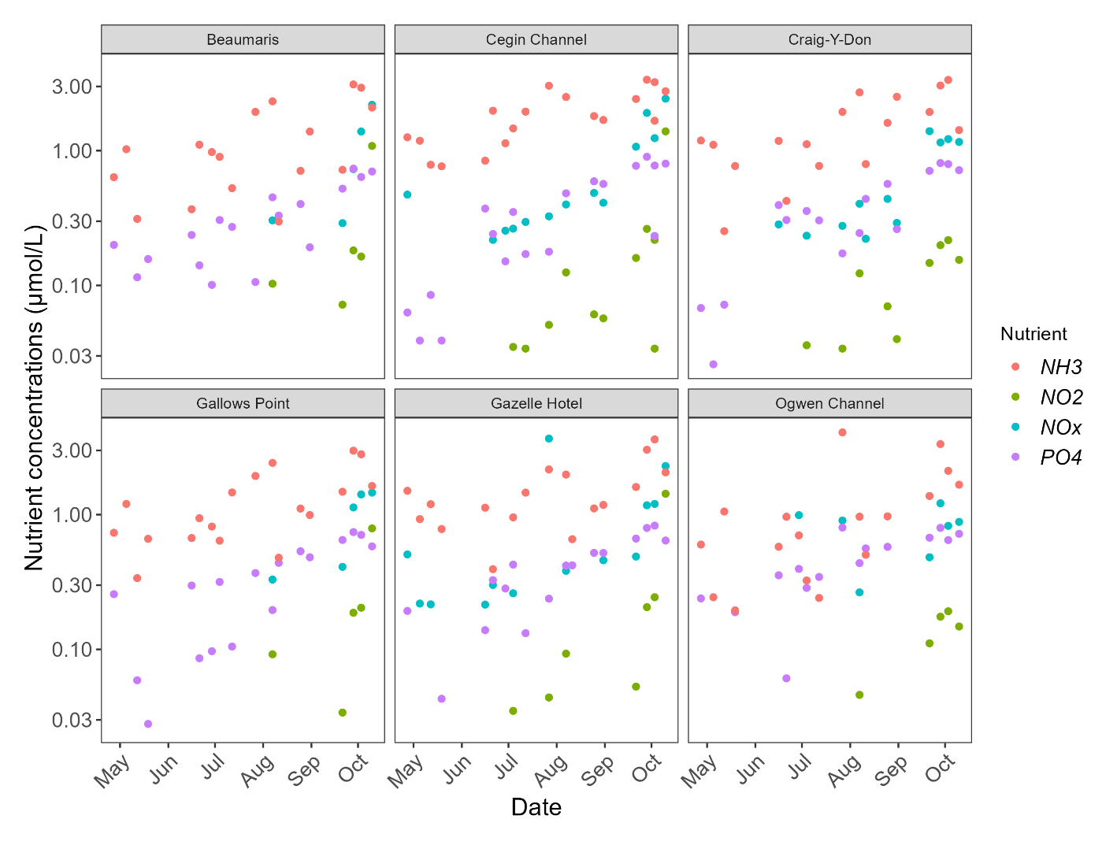
Appendix 1. Nutrient concentrations (µmol/L) NOx: nitrite + nitrate, NO₂: nitrite, PO₄: Phosphate, NH₃: Ammonia, observed in surface water at the six seawater sampling sites (Cegin Channel, Craig-Y-Don, Gazelle Hotel, Gallows Point, Beaumaris, Ogwen Channel) between April – October 2022. Note the log scale of the y axis.

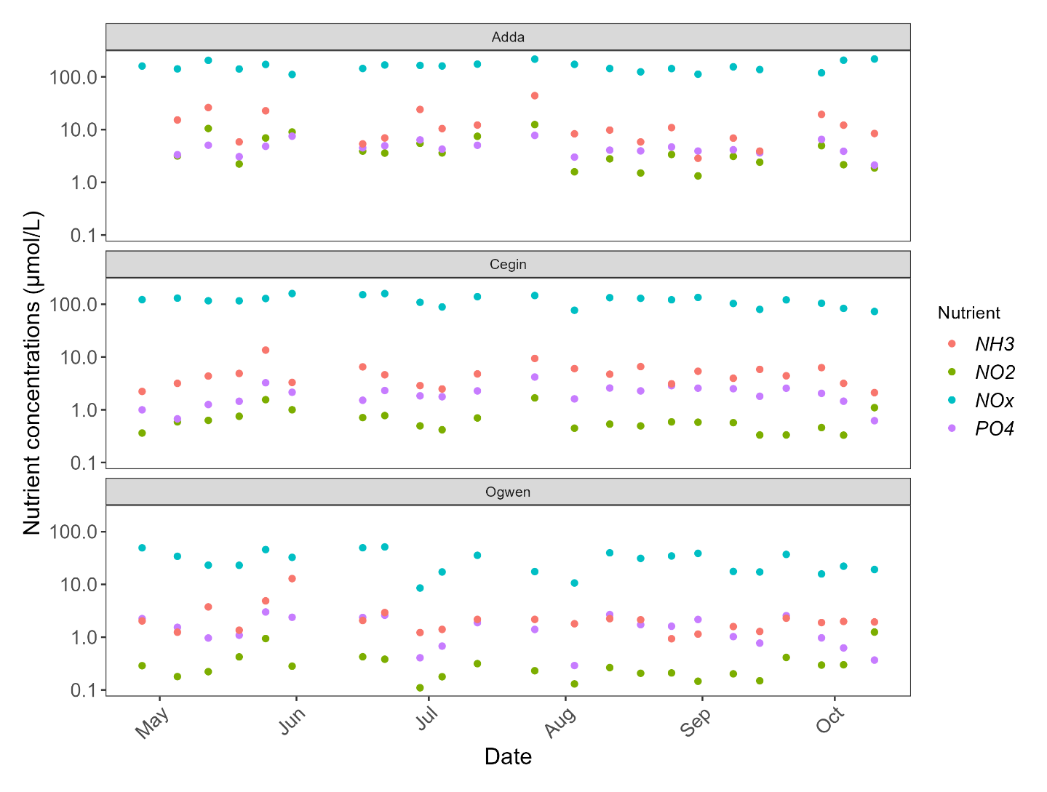Appendix 2. Nutrient concentrations (µmol/L) NOx: nitrite + nitrate, NO₂: nitrite, PO₄: Phosphate, NH₃: Ammonia, observed in surface water at the Afon Adda, Cegin and Ogwen sampling sites between April – October 2022. Note the log scale of the y axis.

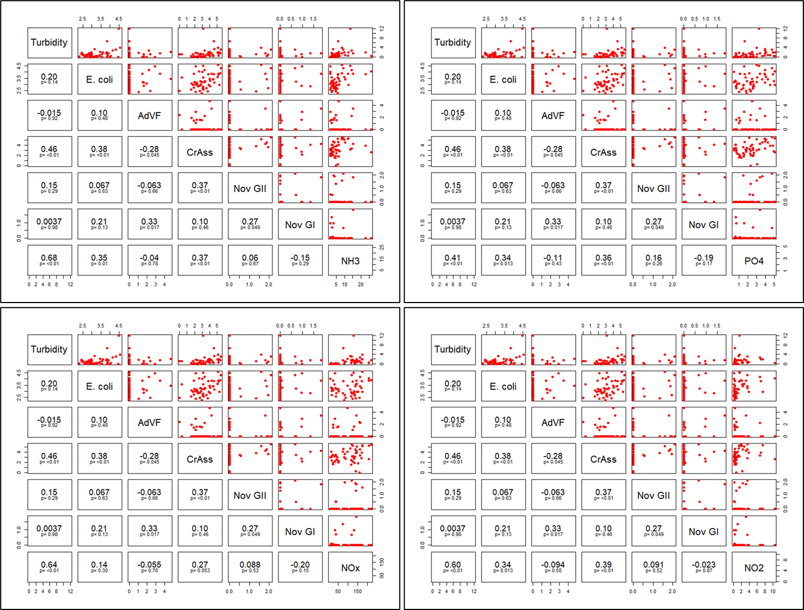Appendix 3. Paired plots and Spearman's correlation coefficient values for nutrients (NOx: nitrite + nitrate, NO₂: nitrite, PO₄: Phosphate, NH₃: Ammonia), turbidity, microbial concentrations (E. coli (CFU/100ml), and viral concentrations (gc/l) (AdVF: human mastadenovirus F, CrAss: crAssphage, NoV GI, GII) for the Afon Adda, Afon Cegin, and Afon Ogwen. E. coli and viral concentration data was log10 transformed.

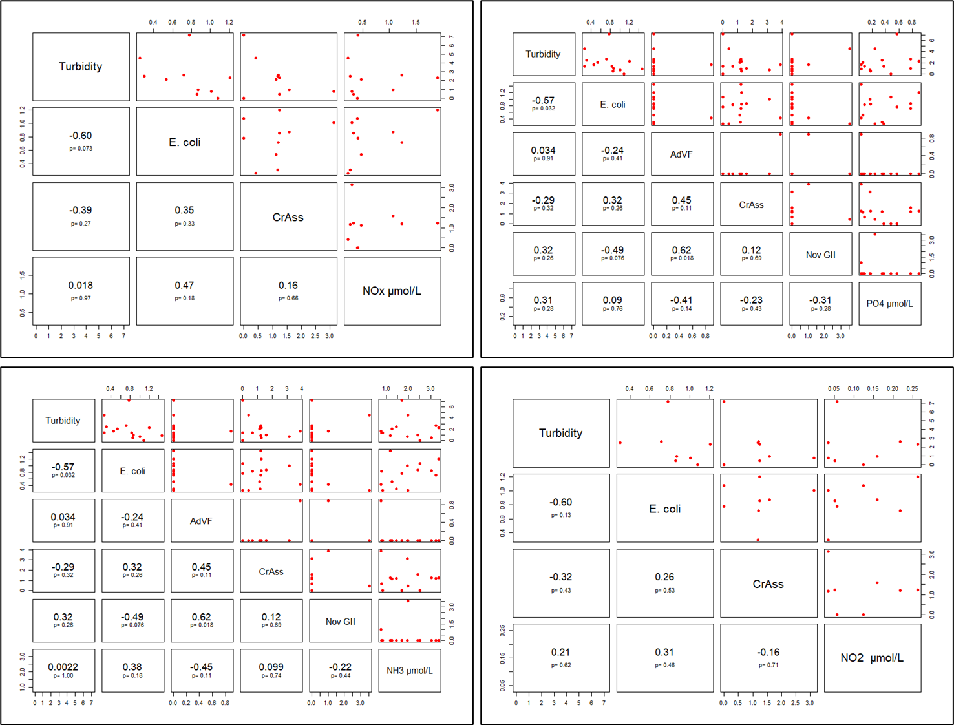Appendix 4. Paired plots and Spearman's correlation coefficient values for nutrients (NOx: nitrite + nitrate, NO₂: nitrite, PO₄: Phosphate, NH₃: Ammonia), turbidity, microbial concentrations (E. coli (CFU/100ml), and viral concentrations (gc/l) (AdVF: human mastadenovirus F, CrAss: crAssphage, NoV GI, GII) for the Cegin Channel seawater site. E. coli and viral concentration data was log10 transformed.

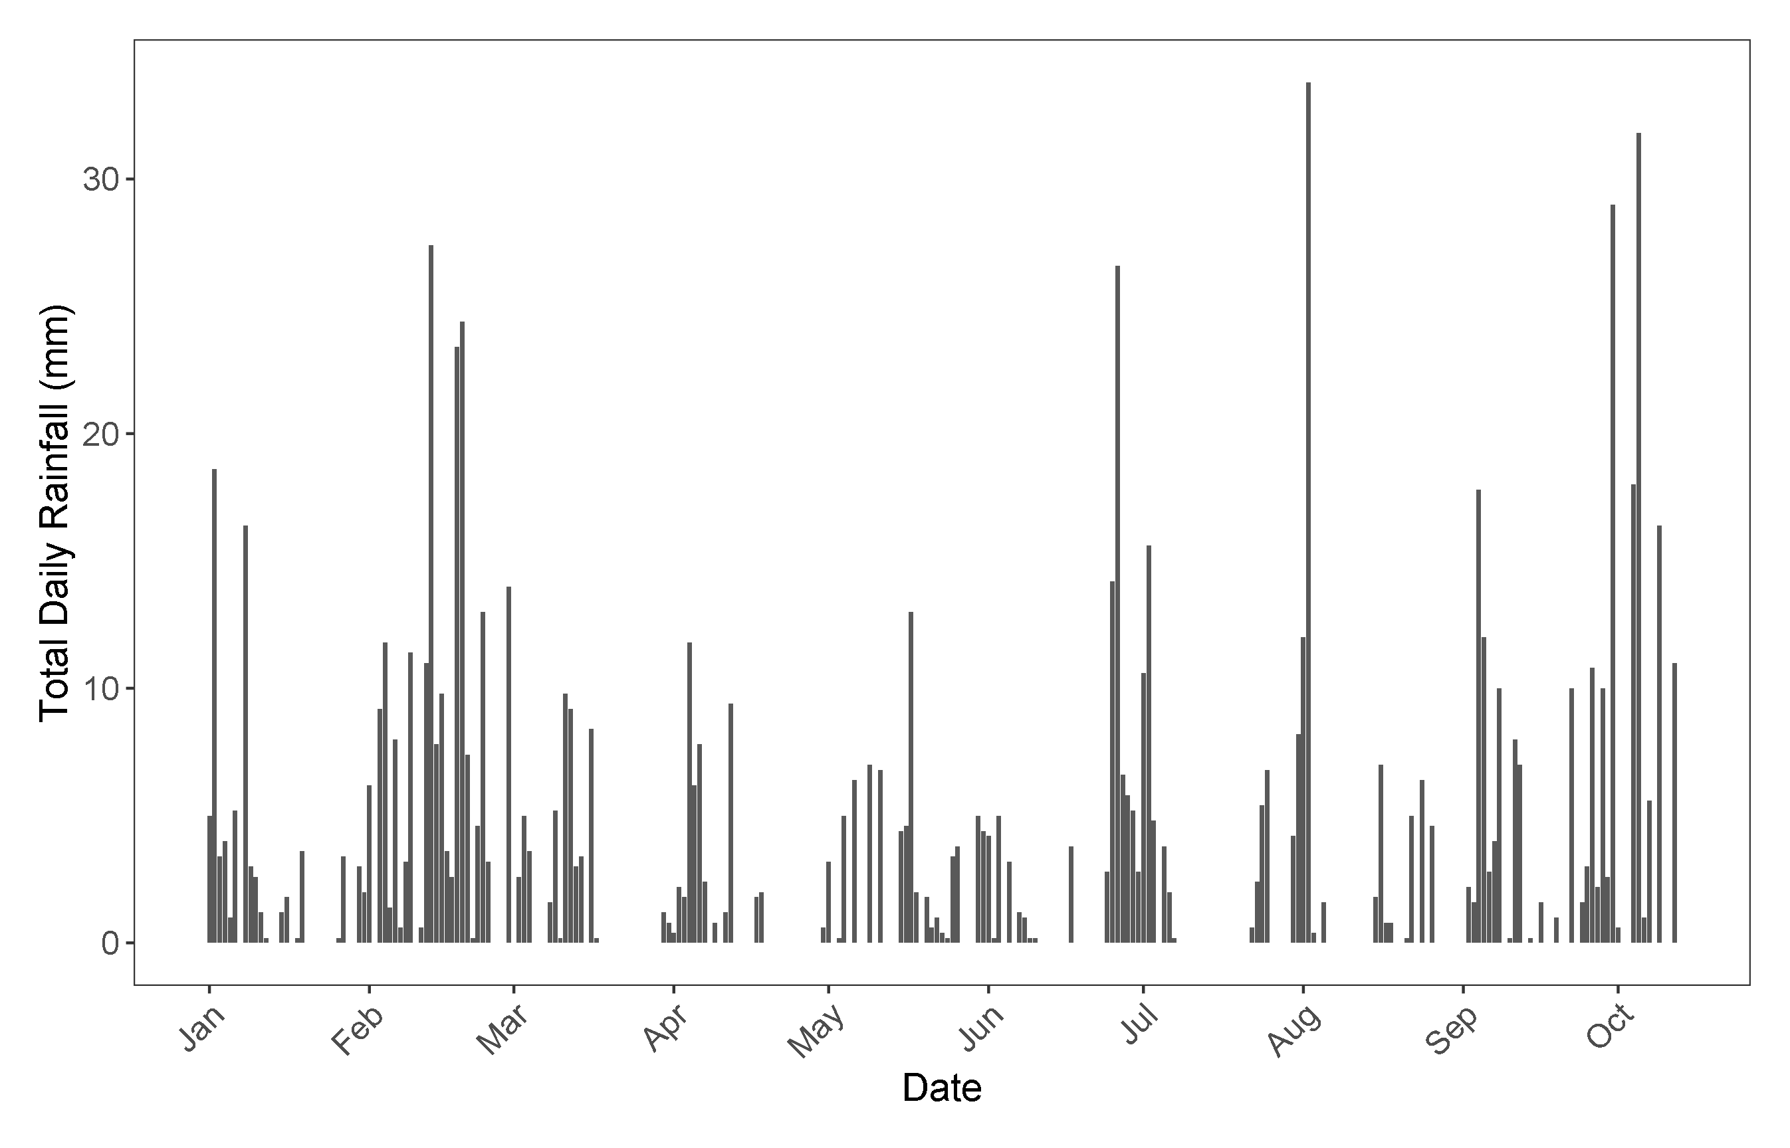
Appendix 5. Total daily rainfall (mm) reported by the Bethesda Quarry NRW rain gauge from January to October 12th, 2022.

Appendix 6. Outline of the primers/probes and reagent mixes used for qPCR quantification of Norovirus, Sapovirus, Hepatitis, MNV, CrAssphage, and Adenoviruses.
Virus | Forward | Reverse | Probe | Amplicon length (bases) | Ta (Annealing temperature) | Kit
RNA virus multiplex assay 2
Norovirus GI | CGCTGGATGCGNTTCCAT | CCTTAGACGCCATCATCATTTAC | FAM-TGGACAGGAGATCGC-MGB | 86 | 60°C | TaqMan Fast 1-step Virus qRT-PCR
Sapovirus GI  and GII | TTGGCCCTCGCCACCTAC | CAAATTAGTGTTTGAGATGGAGGG | HEX-TGGTTCATAGGTGGTAC-MGB | 101
 | GACCAGGCTCTCGCCACCTAC |  |  | 103
Hepatitis E virus | GGTGGTTTCTGGGGTGAC | AGGGGTTGGTTGGATGAA | DO-TGATTCTCAGCCCTTCGC-DDQII | 71
RNA virus multiplex assay 1
Norovirus GII | ATGTTCAGRTGGATGAGRTTC  TCWGA | TCGACGCCATCTTCATTCACA | FAM-AGCACGTGGGAGGGCGATCG-MGB | 89 | 56°C | TaqMan Fast 1-step Virus qRT-PCR
Hepatitis A virus | TCACCGCCGTTTGCCTAG | GGAGAGCCCTGGAAGAAAG | HEX-CCTGGACCTGCAGGAATTAA-BHQ | 173
Adenovirus assay
Mastadenovirus F | GCCTGGGGAACAAGTTCAGA | GCGTAAAGCGCACTTTGTAAG | DO-CAGTCGCTGYGACCT  GTCTGTGGTT-DDQII | 137 | 59°C | QuantiNova Probe qPCR Mix
Atadenovirus | CAGATGGAGCCMCAGCG | TGAAYTGYACSAGATTTTCAGACA | HEX-TCCCTYGCATTTCTA  CCCGCAATGTG-BHQ | 81 | 59°C
CrAssphage assay
CrAssphage | CAGAAGTACAAACTCCTAAAAA  ACGTAGAG | GATGACCAATAAACAAGCCATTAGC | FAM-AATAACGATTTACGTGATGTAAC-TAMRA | 125 | 60°C | QuantiNova Probe qPCR Mix

7. References (and/or Bibliography)

Afon Adda Rain gauge. (2022). River levels, rainfall and sea data. https://rivers-and-seas.naturalresources.wales/Station/1020? (Accessed 17 November 2022).
Baggi, F., Demarta, A., & Peduzzi, R. (2001). Persistence of viral pathogens and bacteriophages during sewage treatment: lack of correlation with indicator bacteria. Research in microbiology, 152(8), 743-751.
Bangor University. (2022). Annual Report 2022. https://www.bangor.ac.uk/about/annual-review (Accessed 24 August 2022).
Barardi, C.R.M., Yip, H., Emsile, K.R., Vesey, G., Raj Shanker, S., & Williams, K.L. (1999). Flow cytometry and RT-PCR for rotavirus detection in artificially seeded oyster meat. International Journal of Food Microbiology, 49, 9–18.
Bazzardi, R., Fattaccio, M. C., Salza, S., Canu, A., Marongiu, E., & Pisanu, M. (2014). Preliminary study on Norovirus, hepatitis A virus, Escherichia coli and their potential seasonality in shellfish from different growing and harvesting areas in Sardinia region. Italian Journal of Food Safety, 3(2).
Bellou, M., Kokkinos, P., & Vantarakis, A. (2013). Shellfish-borne viral outbreaks: a systematic review. Food and environmental virology, 5(1), 13-23.
Bethesda Quarry Rain gauge. (2022). River levels, rainfall and sea data. https://rivers-and-seas.naturalresources.wales/Station/1022 (Accessed 2 November 2022).
Bivins, A., Kaya, D., Ahmed, W., Brown, J., Butler, C., Greaves, J., Leal, R., Maas, K., Rao, G., Sherchan, S., Sills, D., Sinclair, R., Wheeler, R. & Mansfeldt, C. (2022a). Passive sampling to scale wastewater surveillance of infectious disease: Lessons learned from COVID-19. Science of The Total Environment, 835, 155347.
Bivins, A., Lott, M., Shaffer, M., Wu, Z., North, D., Lipp, E. K., & Bibby, K. (2022b). Building-level wastewater surveillance using tampon swabs and RT-LAMP for rapid SARS-CoV-2 RNA detection. Environmental Science: Water Research & Technology, 8(1), 173-183.
Bougeard, M., Le Saux, J. C., Perenne, N., Baffaut, C., Robin, M., & Pommepuy, M. (2011). Modelling of Escherichia coli fluxes on a catchment and the impact on coastal water and shellfish quality 1. JAWRA Journal of the American Water Resources Association, 47(2), 350-366.
Burkhardt III, W., & Calci, K. R. (2000). Selective accumulation may account for shellfish-associated viral illness. Applied and Environmental Microbiology, 66(4), 1375-1378.
Calgua, B., Fumian, T., Rusinol, M., Rodriguez-Manzano, J., Mbayed, V. A., Bofill-Mas, S., & Girones, R. (2013). Detection and quantification of classic and emerging viruses by skimmed-milk flocculation and PCR in river water from two geographical areas. Water research, 47(8), 2797-2810.
Campos, C. J. A., Kershaw, S., Lee, R. J., & Morgan, O. C. (2011). Rainfall and river flows are predictors for β-glucuronidase positive Escherichia coli accumulation in mussels and Pacific oysters from the Dart Estuary (England). Journal of Water and Health, 9, 368-381.
Centre for Environment Fisheries and Aquaculture Science (CEFAS). (2013). Sanitary survey of Menai Strait East. Cefas report on behalf of the Food Standards Agency, to demonstrate compliance with the requirements for classification of bivalve mollusc production areas in England and Wales under EC regulation No. 854/2004.
Centre for Environment Fisheries and Aquaculture Science (CEFAS). (2022). Shellfish monitoring results. https://www.cefas.co.uk/data-and-publications/shellfish-classification-and-microbiological-monitoring/england-and-wales/shellfish-monitoring-results/ (Accessed 10 December 2022).
Chan, M. C., Sung, J. J., Lam, R. K., Chan, P. K., Lai, R. W., & Leung, W. K. (2006). Sapovirus detection by quantitative real-time RT-PCR in clinical stool specimens. Journal of Virological Methods, 134(1-2), 146-153.
Ung, H., Jaykus, L. A., Lovelace, G., & Sobsey, M. D. (1998). Bacteriophages and bacteria as indicators of enteric viruses in oysters and their harvest waters. Water Science and Technology, 38(12), 37-44.
Clements, K., Quilliam, R. S., Jones, D. L., Wilson, J., & Malham, S. K. (2015). Spatial and temporal heterogeneity of bacteria across an intertidal shellfish bed: Implications for regulatory monitoring of faecal indicator organisms. Science of the total environment, 506, 1-9.
Crossan, C., Baker, P. J., Craft, J., Takeuchi, Y., Dalton, H. R., & Scobie, L. (2012). Hepatitis E virus genotype 3 in shellfish, United Kingdom. Emerging infectious diseases, 18(12), 2085.
Devane, M. L., Moriarty, E., Weaver, L., Cookson, A., & Gilpin, B. (2020). Faecal indicator bacteria from environmental sources; strategies for identification to improve water quality monitoring. Water Research, 185, 116204.
Droppo, I. G., Liss, S. N., Williams, D., Nelson, T., Jaskot, C., & Trapp, B. (2009). Dynamic existence of waterborne pathogens within river sediment compartments. Implications for water quality regulatory affairs. Environmental science & technology, 43(6), 1737-1743.
Espinosa, A. C., Arias, C. F., Sánchez-Colón, S., & Mazari-Hiriart, M. (2009). Comparative study of enteric viruses, coliphages and indicator bacteria for evaluating water quality in a tropical high-altitude system. Environmental Health, 8(1), 1-10.
Farkas, K., Varsani, A., Marjoshi, D., Easingwood, R., McGill, E., & Pang, L. (2015). Size exclusion-based purification and PCR-based quantitation of MS2 bacteriophage particles for environmental applications. Journal of virological methods, 213, 135-138.
Farkas, K., Malham, S.K., Peters, D. E., de Rougemont, A., McDonald, J. E., & Jones, D. L. (2017). Evaluation of two triplex one-step qRT-PCR assays for the quantification of human enteric viruses in environmental samples. Food Environmental Virology, 9, 343–349.
Farkas, K., Cooper, D. M., McDonald, J. E., Malham, S. K., de Rougemont, A., & Jones, D. L. (2018). Seasonal and spatial dynamics of enteric viruses in wastewater and in riverine and estuarine receiving waters. Science of the Total Environment, 634, 1174-1183.
Farkas, K., Walker, D. I., Adriaenssens, E. M., McDonald, J. E., Hillary, L. S., Malham, S. K., & Jones, D. L. (2020). Viral indicators for tracking domestic wastewater contamination in the aquatic environment. Water Research, 181, 115926.
Garcia-Garcia, L. M., Campos, C. J. A., Kershaw, S., Younger, A., & Bacon, J. (2021). Scenarios of intermittent E. coli contamination from sewer overflows to shellfish growing waters: the Dart Estuary case study. Marine Pollution Bulletin, 167, 112332.
Garson, J. A., Ferns, R. B., Grant, P. R., Ijaz, S., Nastouli, E., Szypulska, R., & Tedder, R. S. (2012). Minor groove binder modification of widely used TaqMan probe for hepatitis E virus reduces risk of false negative real-time PCR results. Journal of Virological Methods, 186, 157–160.
Gronewold, A. D., & Wolpert, R. L. (2008). Modelling the relationship between most probable number (MPN) and colony-forming unit (CFU) estimates of faecal coliform concentration. Water Research, 42, 3327 – 3334.
Harwood, V. J., Staley, C., Badgley, B. D., Borges, K., & Korajkic, A. (2014). Microbial source tracking markers for detection of faecal contamination in environmental waters: relationships between pathogens and human health outcomes. FEMS microbiology reviews, 38(1), 1-40.
Hot, D., Legeay, O., Jacques, J., Gantzer, C., Caudrelier, Y., Guyard, K., & Andreoletti, L. (2003). Detection of somatic phages, infectious enteroviruses and enterovirus genomes as indicators of human enteric viral pollution in surface water. Water research, 37(19), 4703-4710.
International Organization for Standardization [ISO] 16649-2:2001. Microbiology of food and animal feeding stuffs – Horizontal method for the enumeration of β-glucuronidase-positive Escherichia coli – Part 2: Colony-count technique at 44°C using 5-bromo-4-chloro-3-indoyl β-D-glucuronide.
International Organization for Standardization [ISO] 16649-3:2015. Microbiology of the food chain — Horizontal method for the enumeration of beta-glucuronidase-positive Escherichia coli — Part 3: Detection and most probable number technique using 5-bromo-4-chloro-3-indolyl-ß-D-glucuronide.
International Organization for Standardization [ISO] 16140-4:2020. Microbiology of the food chain — Method validation — Part 4: Protocol for method validation in a single laboratory.
International Organization for Standardization [ISO] 15216-2:2019. Microbiology of the food chain — Horizontal method for determination of hepatitis A virus and norovirus using real-time RT-PCR — Part 2: Method for detection.
International Organisation for Standardisation [ISO] 9308-1:2014. Water quality — Enumeration of Escherichia coli and coliform bacteria — Part 1: Membrane filtration method for waters with low bacterial background flora.
Jarvis, B., Wilrich, C., & Wilrich, P. (2010). Reconsideration of the derivation of Most Probable Numbers, their standard deviations, confidence bounds and rarity values. Journal of Applied Microbiology, 109: 1660–1667.
Jovanovic, D., Hathaway, J., Coleman, R., Deletic, A., & McCarthy, D. T. (2017). Conceptual modelling of E. coli in urban stormwater drains, creeks and rivers. Journal of Hydrology, 555, 129-140.
Kay, D., Kershaw, S., Lee, R., Wyer, M. D., Watkins, J., & Francis, C. (2008). Results of field investigations into the impact of intermittent sewage discharges on the microbiological quality of wild mussels (Mytilus edulis) in a tidal estuary. Water Research, 42(12), 3033-3046.
Kevill, J., Lambert-Slosarska, K., Pellett, C., Woodhall, N., Richardson-O'Neill, I., Pântea, I., Alex-Sanders, N., Farkas, K., & Jones, D. (2022). Assessment of two types of passive sampler for the efficient recovery of SARS-CoV-2 and other viruses from wastewater. Science of The Total Environment, 838, 156580.
Kitajima, M., Oka, T., Takagi, H., Tohya, Y., Katayama, H., Takeda, N., & Katayama, K. (2010). Development and application of a broadly reactive real-time reverse transcription-PCR assay for detection of murine noroviruses. Journal of Virological Methods 169, 269–273.
Lee, R. J., & Morgan, O. C. (2003). Environmental factors influencing the microbiological contamination of commercially harvested shellfish. Water Science and Technology, 47(3), 65-70.
Li, J., Verhagen, R., Ahmed, W., Metcalfe, S., Thai, P., Kaserzon, S., Smith, W., Schang, C., Simpson, S., Thomas, K., Mueller, J., & Mccarthy, D. (2022). In Situ Calibration of Passive Samplers for Viruses in Wastewater. ACS EST Water, Article ASAP, DOI: 10.1021/acsestwater.1c00406.
Love, D. C., Lovelace, G. L., & Sobsey, M. D. (2010). Removal of Escherichia coli, Enterococcus fecalis, coliphage MS2, poliovirus, and hepatitis A virus from oysters (Crassostrea virginica) and hard-shell clams (Mercinaria mercinaria) by depuration. International journal of food microbiology, 143(3), 211-217.
Maalouf, H., Schaeffer, J., Parnaudeau, S., Le Pendu, J., Atmar, R. L., Crawford, S. E., & Le Guyader, F. S. (2011). Strain-dependent norovirus bioaccumulation in oysters. Applied and Environmental Microbiology, 77(10), 3189-3196.
Malham, S. K., Rajko-Nenow, P., Howlett, E., Tuson, K. E., Perkins, T. L., Pallett, D. W., Wang, H., Jago, C. F., Jones, D. L., & McDonald, J. E. (2014). The interaction of human microbial pathogens, particulate material and nutrients in estuarine environments and their impacts on recreational and shellfish waters. Environmental Science: Processes & Impacts, 16, 2145-2155.
Malham, S. K., Taft, H., Cooper, D., Ladd, C., Seymour, S., Robins, PE., Jones, DL., McDonald, J. E., Le Vay, L., & Jones, L. (2017). Review of current evidence to inform selection of environmental predictors for active management systems in classified shellfish harvesting areas. FSA Project FS103001. Report prepared by Bangor University and the NERC Centre for Ecology and Hydrology.
Malham, S. K., Cooper, D., Robins, P., Dickson, N., Farkas, K., Jones, L., Mannion, F., Sorby, R., Winterbourn, B., Thorpe, J., Allender, S., & Le Vay, L. (In prep) Developing an Assurance Scheme for Shellfish and Human Health, project report (to be published by Seafish in 2023).
Mullendore, J. L., Sobsey, M. D., & Shieh, Y. S. C. (2001). Improved method for the recovery of hepatitis A virus from oysters. Journal of Virological Methods, 94(1-2), 25-35.
Muscillo, M., Pourshaban, M., Iaconelli, M., Fontana, S., Di Grazia, A., Manzara, S., & La Rosa, G. (2008). Detection and quantification of human adenoviruses in surface waters by nested PCR, TaqMan real-time PCR and cell culture assays. Water, Air, and Soil Pollution, 191(1), 83-93.
Nguyen, K. H., Senay, C., Young, S., Nayak, B., Lobos, A., Conrad, J., & Harwood, V. J. (2018). Determination of wild animal sources of faecal indicator bacteria by microbial source tracking (MST) influences regulatory decisions. Water research, 144, 424-434.
Oliver, J.D. (2010). Recent findings on the viable but nonculturable state in pathogenic bacteria. FEMS microbiology reviews, 34(4), 415-425.
Schmidt, W., Evers-King, HL., Campos, CJA., Jones, DB., Miller, PI., Davidson, K., & Shutler, JD. (2018). A generic approach for the development of short-term predictions of Escherichia coli and biotoxin in shellfish. Aquaculture Environment Interactions, 10, 173-185.
Stachler, E., Kelty, C., Sivaganesan, M., Li, X., Bibby, K., & Shanks, O. C. (2017). Quantitative crAssphage PCR assays for human faecal pollution measurement. Environmental Science and Technology 51, 9146–9154.
Oliver, D. M., Porter, K. D., Pachepsky, Y. A., Muirhead, R. W., Reaney, S. M., Coffey, R., Kay, D., Milledge, D. G., Hong, E., Anthony, S. G., Page, T., Bloodworth, J. W., Mellander, P. E., Carbonneau, P. E., McGrane, S. J., & Quilliam, R. S. (2016). Predicting microbial water quality with models: over-arching questions for managing risk in agricultural catchments. Science of the Total Environment, 544, 39-47.
Ogorzaly, L., Cauchie, H. M., Penny, C., Perrin, A., Gantzer, C., & Bertrand, I. (2013). Two-day detection of infectious enteric and non-enteric adenoviruses by improved ICC-qPCR. Applied microbiology and biotechnology, 97(9), 4159-4166.
Pol-Hofstad, I. E., & Jacobs-Reitsma, W. F. (2021). Validation of the TBX pour plate method (ISO 16649-2) for the enumeration of Escherichia coli in Live Bivalve Molluscs: renewal study for alignment with EN ISO 16140-2: 2016.
Polo, D., Schaeffer, J., Teunis, P., Buchet, V., & Le Guyader, F. S. (2018). Infectivity and RNA persistence of a norovirus surrogate, the Tulane virus, in oysters. Frontiers in microbiology, 9, 716.
Robins, P. E., Farkas, K., Cooper, D., Malham, S. K., & Jones, D. L. (2019). Viral dispersal in the coastal zone: A method to quantify water quality risk. Environment international, 126, 430-442.
Rodriguez-Lazaro, D., Cook, N., Ruggeri, F. M., Sellwood, J., Nasser, A., Nascimento, M. S. J., D’Agostino, M., Santos, R., Saiz, C. J., Rzezutka, A., Bosch, A., Girones, R., Carducci, A., Muscillo, M., Kovac, K., Diez-Valcarce, M., Vantarakis, A., von Bonsdorff, C. H., de Roda Husman, A. M., Hernandez, M., & van der Poel, W. H. (2012). Virus hazards from food, water and other contaminated environments. FEMS microbiology reviews, 36(4), 786-814.
Sabar, M. A., Honda, R., & Haramoto, E. (2022). CrAssphage as an indicator of human-faecal contamination in water environment and virus reduction in wastewater treatment. Water Research, 221, 118827.
Sedji, M. I., Varbanov, M., Meo, M., Colin, M., Mathieu, L., & Bertrand, I. (2018). Quantification of human adenovirus and norovirus in river water in the north-east of France. Environmental science and pollution research, 25(30), 30497-30507.
Stewart, J. R., Gast, R. J., Fujioka, R. S., Solo-Gabriele, H. M., Meschke, J. S., Amaral-Zettler, L. A., del Castillo, E., Polz, M. F., Collier, T. K., Strom, M. S., Sinigalliano, C. D., Moeller, D. R. P., & Holland, A. F. (2008). The coastal environment and human health: microbial indicators, pathogens, sentinels and reservoirs. Environmental health, 7(2), 1-14.
The Bathing Water Regulations. (2013). Legislation.gov.uk. (Accessed 10 November 2022).
Vincent-Hubert, F., Wacrenier, C., Morga, B., Lozach, S., Quenot, E., Mège, M., Lecadet, C., Gourmelon, M., Hervio-Heath, D., & Le Guyader, F. (2021). Passive Samplers, a Powerful Tool to Detect Viruses and Bacteria in Marine Coastal Areas. Frontiers In Microbiology, 12, 631174.
Walker, D. I., Younger, A., Stockley, L., & Baker-Austin, C. (2018). Escherichia coli testing and enumeration in live bivalve shellfish–present methods and future directions. Food microbiology, 73, 29-38.
Winterbourn, J. B., Clements, K., Lowther, J. A., Malham, S. K., McDonald, J. E., & Jones, D. L. (2016). Use of Mytilus edulis biosentinels to investigate spatial patterns of norovirus and faecal indicator organism contamination around coastal sewage discharges. Water Research, 105, 241-250.
Wolf, S., Hewitt, J., & Greening, G. E. (2010). Viral multiplex quantitative PCR assays for tracking sources of faecal contamination. Applied and Environmental Microbiology, 76.
Zimmer-Faust, A. G., Brown, C. A., & Manderson, A. (2018). Statistical models of faecal coliform levels in Pacific Northwest estuaries for improved shellfish harvest area closure decision making. Marine Pollution Bulletin, 137, 360-369.

